PROJECT VERIFICATION FORM

PROJECT TITLE : FACILITIES BOOKING SYSTEM

This final project is to practice knowledge and skills related to the field based to the experience and skills of the trainee on;
- CoCu 1- APPLICATION SYSTEMS PROGRAMMING
- CoCu 2- APPLICATION DATABASE PROGRAMMING
- CoCu 3- APPLICATION DATA ENTRY ADMINISTRATION
- CoCu 4- APPLICATION SYSTEMS DEVELOPMENT ADMINISTRATION
- CoCu 5- INFRA SYSTEMS INTERFACE DESIGNING
- CoCu 6- APPLICATION SYSTEMS FUNCTIONAL TESTING
- CoCu 7- APPLICATION SYSTEMS TECHNICAL SUPPORT

I declare that the results of the project report are made by practicing knowledge and skills related to the field based on experience and skills without imitating any sources.

SIGNATURE OF APPLICANT :
NAME : KELVIN CHAN
NO. IDENTITY CARD : 030317-01-1195
DATE :

SIGNATURE OF APPLICANT :
NAME : WONG KHER ER
NO. IDENTITY CARD : 021201-08-1517
DATE :

SIGNATURE OF APPLICANT :
NAME : GOH YONG YU
NO. IDENTITY CARD : 021209-08-0383
DATE :

I declare that I have read this project report and in my opinion this report is sufficient
in terms of scope and quality for the award of the Malaysian Skills Diploma (DKM).

SIGNATURE OF SUPERVISOR :
NAME : Mr. CHEN SHAO XI
DATE :

SIGNATURE OF EXTERNAL :
VERIFICATION OFFICER (PPL) :
NAME :
DATE :

ACKNOWLEDGEMENTS

Firstly, we would like to express our sincere gratitude to our supervisor Mr. CHEN SHAO XI for the continuous support of our diploma study and related research, for his patience, motivation, and immense knowledge.

Besides our supervisor, we would like to thank our Programming lecturer, Mr.CHEN SHAO XI for his insightful comments and encouragement, but also for the hard question which gave us incentive to widen our research from various perspectives. Sincere thanks also goes to college principal, Mr.KC Neoh,who provided us an opportunity and who gave access to the laboratory and research facilities. Without his precious support, it would not be possible to conduct this final project.

Thank you to our fellow lab mates in for the intellectually stimulating discussions, for the sleepless nights we were working together before deadlines, and for all the fun we have had in the last one years.

Last but not the least, we would like to thank our families for supporting us spiritually throughout writing this thesis.

Thank you.

ABSTRACT
This paper describes a reservation system for organizations, schools or businesses that offer computer facilities for rent internally. Designed to simplify and optimize the equipment rental process, the system provides an efficient and reliable solution that enables users to easily book the required computer equipment. Key features of the system include user authentication and privilege management, equipment information and status management, booking and de-booking, reminder and notification functions, reporting and statistical functions, as well as user feedback and evaluation. Through the booking system for renting computer facilities, users are able to save time, avoid conflicts and improve equipment utilization. The system can be widely used in schools, libraries, enterprises and other organizations to provide convenient and efficient equipment rental services and better working and learning experience for users. In the future, we will further optimize the user interface and user experience of the system and add more customization options to meet the specific needs of different organizations. We will also consider integrating more advanced technologies, such as Internet of Things (IoT) device tracking, to enhance the intelligence of device management.

CONTENT
PROJECT VERIFICATION FORM I
ACKNOWLEDGEMENTS IV
ABSTRACT V
CONTENT VI
LIST OF TABLE VII
LIST OF FIGURES IX
LIST OF SYMBOL X
LIST OF PLAT / PICTURE XI
APPENDIX XIII

CHAPTER 1 1
INTRODUCTION 1
1.1 PROJECT INTRODUCTION 1
1.2 PROBLEM STATEMENT 2
1.4 PROJECT SCOPE 4
1.5 LIMITATIONS 5
1.6 SIGNIFICANCE 6

CHAPTER 2 7
LITERATURE REVIEW 7
2.1 INTRODUCTION 7
2.2 PREVIOUS SYSTEM 7
2.3 CURRENT SYSTEM 8

CHAPTER 3 10
RESEARCH METHODOLOGY 10
3.1 INTRODUCTION 10
3.2 RESEARCH DESIGN 10
3.2.1 WATERFALL MODEL 10
3.2.2 FLOWCHART 11
3.2.3 PROJECT TESTING PROCESS 13
3.3 DATABASE DESIGN 14
3.4 HARDWARE CONFIGURATION 18
3.6 SOFTWARE FEATURES 19
3.6.1 PHP 19
3.7 PROJECT FUNCTIONS 32
3.9.1 SOFTWARE USED AND COSTS 36
3.9.2 HARDWARE USED AND COSTS 36
3.9.3 TOTAL COSTS 37

CHAPTER 4 38
PROJECT DISCOVERY AND ANALYSIS 38
4.1 INTRODUCTION 38
4.2.1 WEBSITE STATISTICS AND SURVEY RESULTS 39

CHAPTER 5 43
DISCUSSION, RECOMMENDATIONS AND CONCLUSIONS 43
5.1 DISCUSSION 43
5.1 PROJECT ISSUES 43
5.4 RECOMMENDATION 44
5.5 CONCLUSION 44

REFERENCES 46
ATTACHMENT 47

LIST OF TABLE

NO. | DESCRIPTION | PAGES
Table 2.4 | COMPARISON OF EXISTING SYSTEM | 10
Table 3.9.1 | SOFTWARE USED AND COSTS | 42
Table 3.9.2 | HARDWARE USED AND COSTS | 42
Table 3.9.3 | TOTAL COSTS | 42

LIST OF FIGURES
NO. | DESCRIPTION | PAGES
Figure 3.2.1 | WATERFALL METHODOLOGY PHASES | 12
Figure 3.2.2 | E-COMMERCE FLOWCHART | 13
Figure 3.2.3 | E-COMMERCE TESTING PROCESS | 14
Figure 3.8.1 | GANTT CHART 1 | 40
Figure 3.8.2 | GANTT CHART 2 | 40
Figure 3.8.3 | GANTT CHART 3 | 41
Figure 4.2.1.1 | PIE CHART 1 | 45
Figure 4.2.1.2 | PIE CHART 2 | 45
Figure 4.2.1.3 | PIE CHART 3 | 46
Figure 4.2.1.4 | PIE CHART 4 | 46
Figure 4.2.1.5 | PIE CHART 5 | 47
Figure 4.2.1.6 | PIE CHART 6 | 47
Figure 4.2.1.7 | PIE CHART 7 | 48
Figure 4.2.1.8 | PIE CHART 8 | 48
Figure 4.2.1.9 | PIE CHART 9 | 49
Figure 4.2.1.10 | PIE CHART 10 | 49

SYMBOLS | PURPOSE
FYP | FINAL YEAR PROJECT
DKM | DIPLOMA KEMAHIRAN MALAYSIA
JT | JOB TRAINING
JPK | JABATAN PEMBANGUNAN KEMAHIRAN

LIST OF SYMBOL

LIST OF PLAT / PICTURE
NO. | DESCRIPTION | PAGES
Image 3.3.1 | CUSTOMER TABLE | 16
Image 3.3.2 | SUPER ADMINS TABLE | 16
Image 3.3.3 | ORDER TABLE | 16
Image 3.3.4 | PAYMENT TABLE | 17
Image 3.3.5 | PRODUCT TABLE | 17
Image 3.3.6 | PRODUCT PHOTO TABLE | 18
Image 3.3.7 | PRODUCT SIZE TABLE | 18
Image 3.3.8 | PRODUCT COLOR TABLE | 18
Image 3.3.9 | SHOPPING COSTS TABLE | 19
Image 3.3.10 | SETTING TABLE | 19
Image 3.3.11 | SLIDER TABLE | 20
Image 3.3.12 | SOCIAL TABLE | 20
Image 3.3.13 | TOP CATEGORY TABLE | 20
Image 3.3.14 | MID CATEGORY TABLE | 21
Image 3.3.15 | END CATEGORY TABLE | 21
Image 3.3.16 | PAYMENT TABLE | 21
Image 3.3.17 | PAGE TABLE | 22
Image 3.3.18 | FAQ TABLE | 22
Image 3.7.1.1 | INDEX PAGE (NOT LOGGED IN) | 28
Image 3.7.1.2 | INDEX PAGE(NOT LOGGED IN) | 28
Image 3.7.1.3 | INDEX PAGE(NOT LOGGED IN) | 29
Image 3.7.1.4 | INDEX PAGE(NOT LOGGED IN) | 29
Image 3.7.2 | PRODUCT DETAILS PAGE(NOT LOGGED IN) | 29
Image 3.7.3.1 | CATEGORIES PAGE | 30
Image 3.7.3.2 | CATEGORIES PAGE | 30
Image 3.7.4 | CART PAGE(NOT LOGGED IN) | 30
Image 3.7.5 | CHECKOUT PAGE(NOT LOGGED IN) | 31
Image 3.7.6 | LOGIN PAGE | 31
Image 3.7.7 | REGISTER PAGE | 31
Image 3.7.8 | SERACH | 32
Image 3.7.9 | ABOUT US | 32
Image 3.7.10 | FAQ | 32
Image 3.7.11 | USER DASHBOARD | 33
Image 3.7.12 | UPDATE PROFILE | 33
Image 3.7.13 | UPDATE SHIPPING INFO | 34
Image 3.7.14 | UPDATE PASSWORD | 34
Image 3.7.15 | ORDER HISTORY | 35
Image 3.7.16 | SUPER ADMIN LOGIN PAGE | 35
Image 3.7.17 | SUPER ADMIN DASHBOARD | 36
Image 3.7.18 | SUPER ADMIN PROFILE | 36
Image 3.7.19 | SUPER ADMIN WEBSITE SETTING | 36
Image 3.7.20 | SUPER ADMIN PAGE SETTING | 37
Image 3.7.21 | SUPER ADMIN SHOP SETTING | 37
Image 3.7.22 | SUPER ADMIN PRODUCT MANAGEMENT | 37
Image 3.7.23 | SUPER ADMIN ORDER MANAGEMENT | 38
Image 3.7.24 | SUPER ADMIN MANAGE SLIDER | 38
Image 3.7.25 | SUPER ADMIN REGISTERED CUSTOMER | 38
Image 3.7.26 | SUPER ADMIN FAQ | 39

 | APPENDIX
NO | DESCRIPTION | PAGE
 | ATTACHMENT | 59-75

CHAPTER 1

INTRODUCTION

1.1 PROJECT INTRODUCTION
Project Background: Facility Booking System
In modern society, the demand for various facilities, including meeting rooms, training rooms, sports arenas, and equipment, is steadily increasing. To more effectively manage and utilize these facilities, many organizations and institutions require an efficient facility booking system. Such a system can assist them in better planning, organizing, and monitoring various activities, improving resource utilization efficiency, reducing conflicts and duplicate reservations, thereby enhancing overall work efficiency.

Traditional manual facility booking methods present numerous issues, such as conflicts in reservations, difficulty in tracking resource utilization, and lack of transparency in information. Therefore, introducing an advanced facility booking system will help address these issues, providing a more convenient, efficient, and transparent facility management solution.

The facility booking system will offer users an intuitive and user-friendly platform, allowing them to easily check the availability of facilities, submit booking requests, and receive real-time confirmation. The system will support bookings for various types of facilities, including meeting rooms, sports arenas, laboratories, and also handle equipment reservation needs."

1.2 PROBLEM STATEMENT

a) the lack of an effective notification system to inform users of changes in booking status or cancellations in a timely manner causes inconvenience and confusion.
b) The current process does not allow users to access the availability status of computer equipment in real time, resulting in the inability to rent the required equipment in a timely manner in case of emergency.

c) the system currently does not provide a history of equipment borrowing, which lacks an effective analysis and planning basis for equipment utilization and demand trends.
1.3 RESEARCH OBJECTIVE
With our project, we will solve the problem statements stated in the problem statement
- User Experience Analysis: Evaluate the user experience of the facility booking system through user feedback, user behavioral data, and user testing. Identify potential improvement points to ensure the system's usability and user satisfaction.
- System Performance Assessment: Assess the system's performance, including response time, concurrent user processing capacity, and stability. This helps ensure that the system remains efficient even under high loads.

1.4 PROJECT SCOPE

Member
- Allow users to create accounts and undergo authentication to ensure system security.
- Provide users with an interface to view rentable devices, supporting search and filtering based on various criteria.
- Enable users to easily reserve and cancel bookings for required computer equipment.

Super Admin
- Provide admin login functionality to ensure system security, allowing management of user permissions.
- Allow administrators to add, edit, and delete device information, including model, configuration, and availability status.
- Provide admin approval for user device reservation requests, ensuring adherence to the established process.
- Enable admins to view user feedback and evaluations for prompt handling and system improvement.
- Provide a clear process for device maintenance and cleaning to ensure stable equipment status and a positive user experience.
- Implement an effective mechanism for resolving conflicts or duplications when multiple users book the same equipment simultaneously.

1.5 LIMITATIONS

Network Connectivity Dependency: Current facility booking systems often rely on cloud platforms, introducing a certain level of dependency on a stable internet connection. Users may face accessibility issues when the network is unstable or disconnected.
Technology Proficiency Variability: Differences in users' technology proficiency can impact their utilization of facility booking systems. Some users may be unfamiliar with online systems, leading to usability challenges, especially for older or less technologically proficient individuals.

1.6 SIGNIFICANCE

- The webpage has a clean and user-friendly interface.
- Items or locations automatically expire when the specified time is reached.
- Automatic alerts pop up to remind the user.
- Historical records can be viewed.
- Passwords can be changed using the verification code sent via email.

CHAPTER 2

LITERATURE REVIEW

2.1 INTRODUCTION

The facility booking system is a web-based facility reservation software that provides complete controllability to manage shared and rentable facilities and resources. It streamlines the reservation and usage of common & individual facilities/equipment by businesses within a building. Facility booking, approval, and billing operations across organizations enhance operational efficiency. Meeting rooms, conference halls, office space, auditoriums, sports facilities, high-cost equipment, training facilities, etc., can be booked through the system seamlessly.

2.2 PREVIOUS SYSTEM

In the past, there may have been traditional manual or basic facility management systems, including paper calendars, spreadsheets, or simple database systems. These systems might have had the following characteristics:
Manual Calendar Systems: In the form of paper or electronic spreadsheets, people manually marked the usage of facilities, making it prone to conflicts and inaccurate information.
Basic Database Systems: Some organizations may have used basic database systems to record basic information and reservation details for facilities. However, such systems may lack user-friendliness and advanced functionalities.
Simple Reservation Forms: Organizations might have provided simple forms for users to fill out for facility reservations. However, this approach is susceptible to inconsistent information and resource conflicts.

2.3 CURRENT SYSTEM

Modern facility booking systems typically leverage advanced technologies and features to better meet user needs and enhance efficiency. Here are some possible current system features:
Online Booking Platform: Facility booking systems are often cloud-based online platforms, allowing users convenient access through web pages or mobile applications.
Real-time Availability View: Users can view the real-time availability of facilities, understanding which facilities are available at specific times to avoid conflicts and duplicate reservations.
Support for Multiple Facility Types: Current systems often support various facility types, including meeting rooms, sports arenas, laboratories, etc., catering to different booking requirements.
Automated Conflict Detection: The system incorporates automated conflict detection features to prevent duplicate reservations during the same time period, improving resource utilization efficiency.
Personalized User Experience: Users can create personal accounts to view booking history, set reminders, and customize preferences, enhancing the overall user experience.
Electronic Notifications and Reminders: The system can send users information about booking statuses, changes, or cancellations through email, SMS, or in-app notifications, facilitating timely communication.

2.4 COMPARISON OF THE SYSTEM

Parameters | Facilities Booking System | Paper Work
Type of System | Stand alone | Traditional handwritten or printed documents and forms.
Application Use | Use Xampp Server | Used for recording and processing various information, such as meeting reservations, event applications, etc.
Objective of  System | The Facilities Booking System is designed to manage facility reservations and usage. | Record information for future reference.Provide a non-digital way to organize and track workflow.
Advantages | All administrative functions and application system data are designed to be centrally stored and unique for the entire organization. | Simplicity: Easier to implement for simple tasks and small-scale organizations. Low cost: No need for special technical or software support."

Table 2.4 Comparison of existing system

CHAPTER 3

RESEARCH METHODOLOGY

3.1 INTRODUCTION

To develop a Facilities Booking System for Synergy College, it is essential to employ a systematic development process. Choosing a suitable approach requires a thorough comparison of methodologies before applying them to the project. Numerous factors influence the selection of a methodology, and it depends on project planning and timeline considerations. The figure below illustrates the common phases of the System Development Life Cycle (SDLC), which will guide the development of the Facilities Booking System.

3.2 RESEARCH DESIGN

3.2.1 WATERFALL MODEL
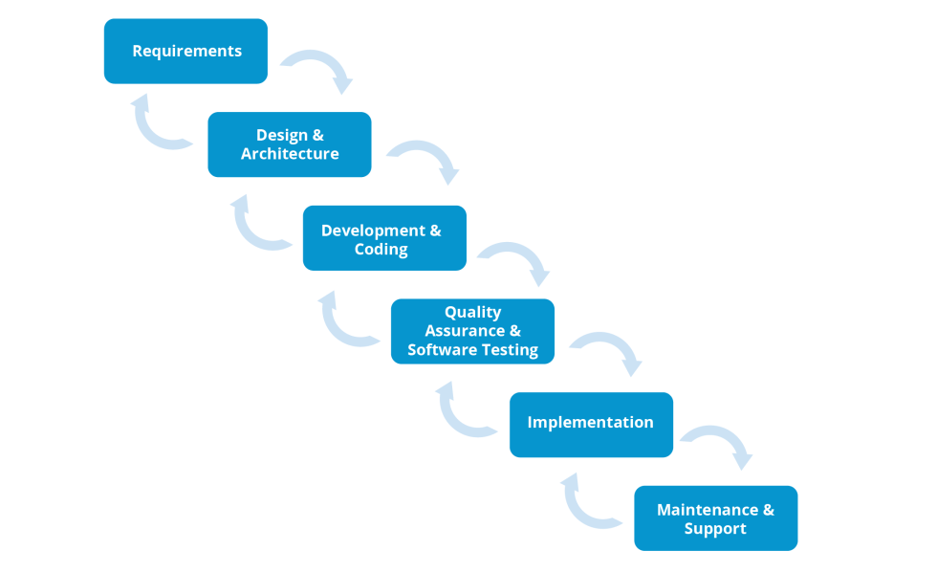

Figure 3.2.1: Waterfall methodology phases

3.2.2 FLOWCHART
Admin
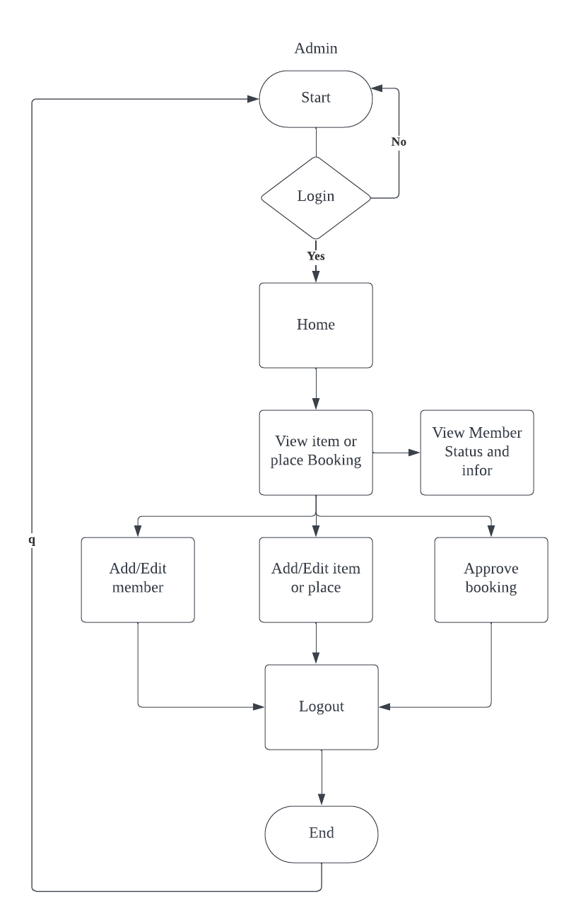
Figure 3.2.2 Admin Flowchart
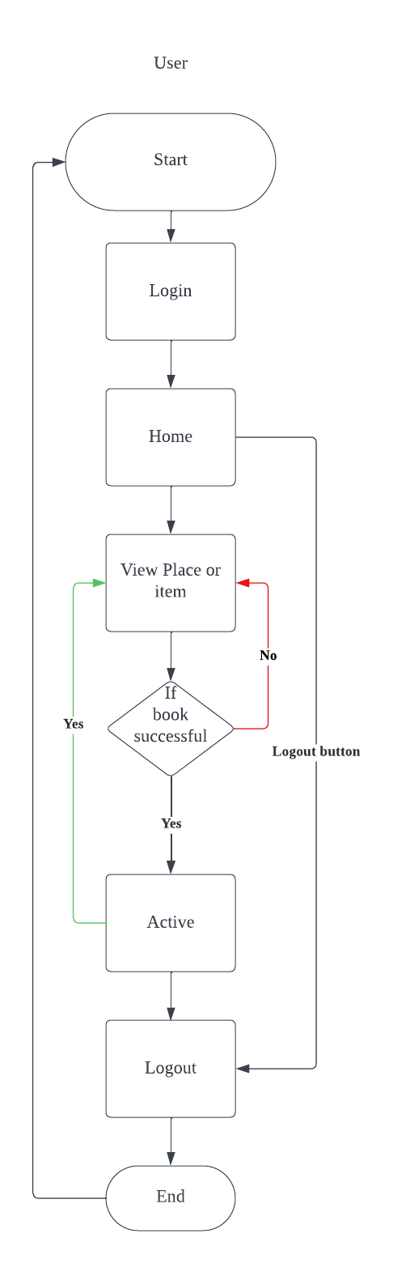
User

Figure 3.2.2 User Flowchart

3.2.3 PROJECT TESTING PROCESS

The Installation of Test System Developed

Prototype Testing System on Stage

Testing Database

Testing Interface Display System

Continuous Test Database Home

Suitable Testing Code in Program

Scope of Testing System to Meet Consumer Requirement

Operational Testing System By Computer

Suitable To Testing System Functions

Testing To Use The System

Summary of The System Advantage and Disadvantage

Testing Booking Data Review

Facilities Booking Data Review

Facilities Booking Transaction Data Review

Facilities Booking Data Review

Facilities Booking System Conception Qualified

Figure 3.2.3 E-commerce Testing Process

3.3 DATABASE DESIGN

The data in the Facilities Booking System needs to be stored and retrieved from a database. Designing the database is an integral part of the system design process. Data elements and data structures to be stored have been identified during the analysis stage. They are organized and assembled to design the data storage and retrieval system.

A database is a collection of interrelated data stored with minimal redundancy to serve many users quickly and efficiently. The overarching objective is to make database access easy, quick, cost-effective, and flexible for the user. Relationships are established between data items, and unnecessary data items are eliminated. Normalization is performed to achieve internal consistency of data, minimize redundancy, and maximize stability. This ensures the minimization of required data storage, reduces the chances of data inconsistencies, and optimizes for updates.

3.3.1 USER LOGIN TABLE

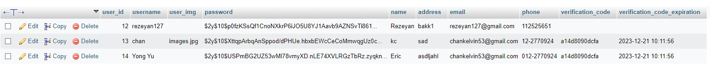
Image 3.3.1 Login Table

3.3.2 ADMINS TABLE
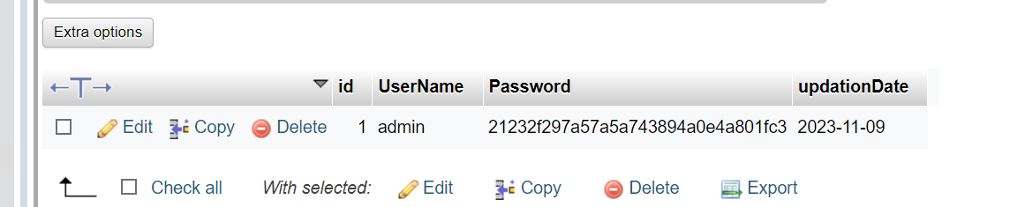
Image 3.3.2 Admins Table

3.3.3 ITEM TABLE
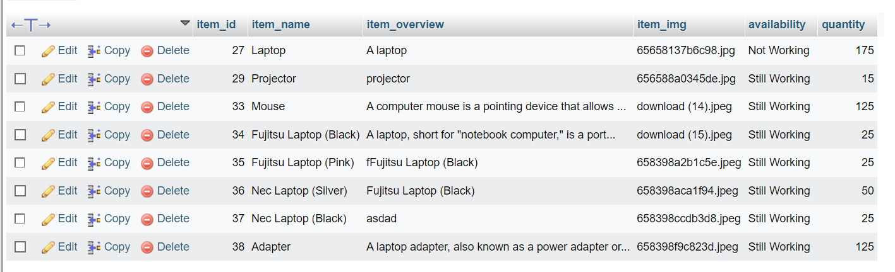
Image 3.3.3 Password Recovery Table

3.3.4 ITEM APPOINTMENT TABLE
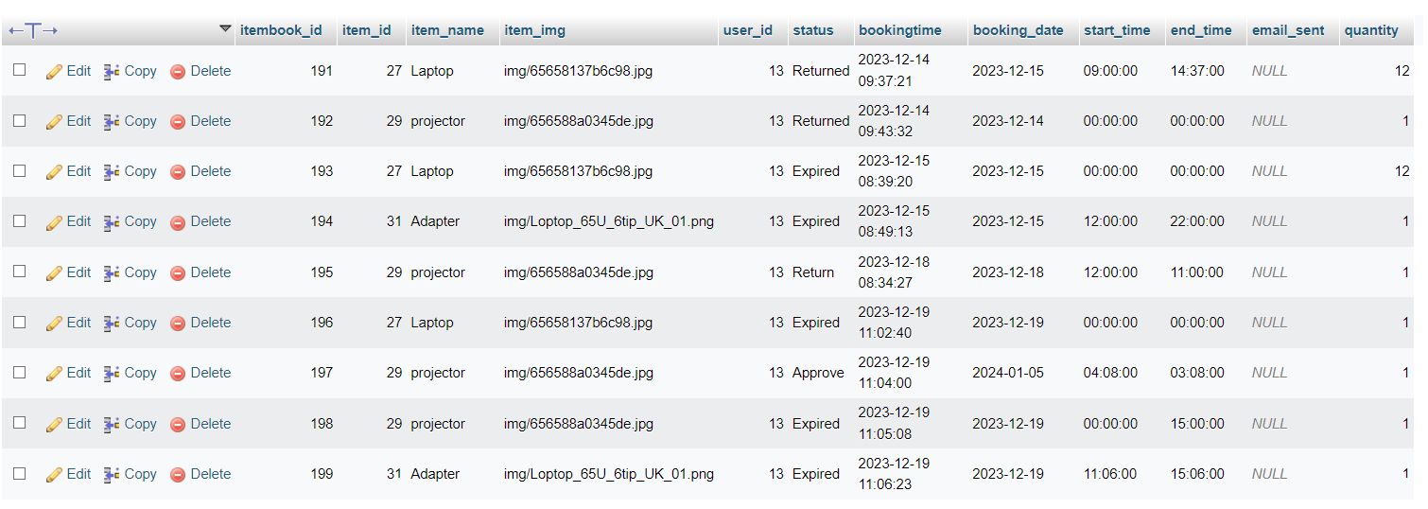
Image 3.3.4 Books Table
3.3.5 PLACE TABLE
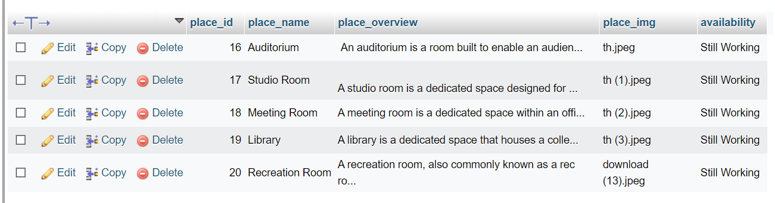
Image 3.3.4 Student Details Table

3.3.6 PLACE APPOINTMENT TABLE
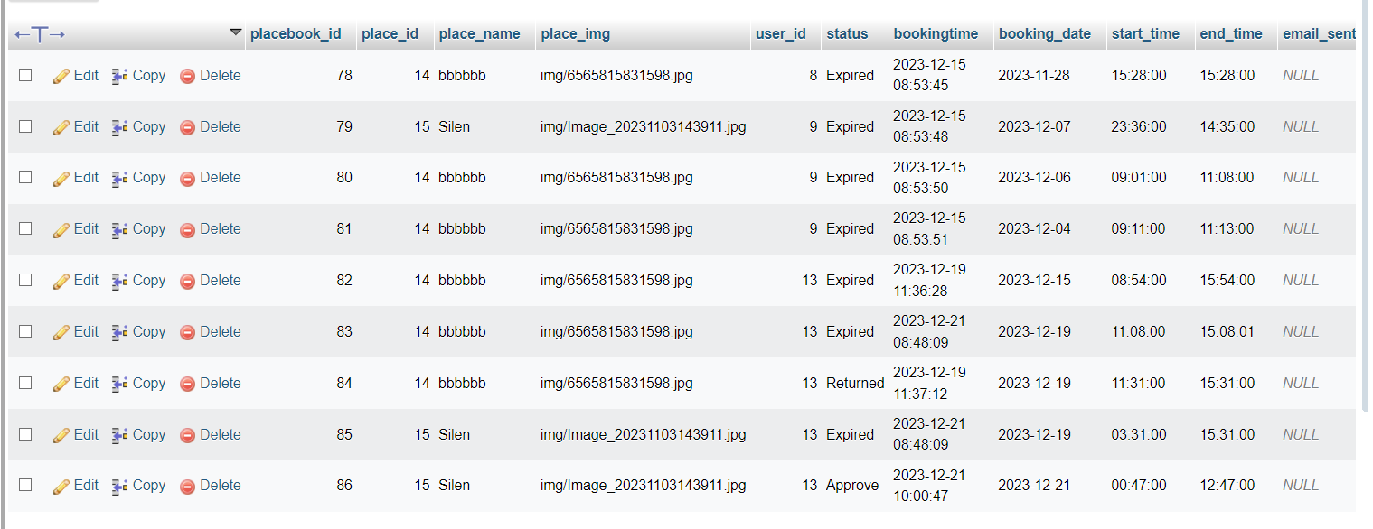
Image 3.36 Borrow Book Table

3.4 HARDWARE CONFIGURATION

3.4.1 Intel(R) Core(TM) i5-10300H CPU @ 2.50GHz
3.4.2 16.00 GBRAM

3.4.3 NVMe Lexar 500GB SSD
3.4.4 NVMe WDC PC SN530 SDB
3.4.5 "15.6" LCD (1920 x 1080) 144Hz"
3.4.6 NVIDIA GeForce GTX 1650 Ti
Note: This is not the “System Requirements”.

3.5 SOFTWARE CONFIGURATION

3.5.1 OS : Windows 11 Home

3.5.2 Xampp (PHP, MySQL, Apache, and PHPMyAdmin)

3.5.3 Visual Studio Code (Code Editor)

3.5.4 Filezilla

3.6 SOFTWARE FEATURES

3.6.1 PHP
PHP (Hypertext Preprocessor):
PHP is a server-side scripting language designed for web development. It was created by Rasmus Lerdorf in 1994 and has since become one of the most popular languages for building dynamic websites. PHP is open-source, meaning its source code is freely available, and it can run on various platforms, including Windows, Linux, and macOS.

Key Features:
Server-Side Scripting: PHP is executed on the server, generating HTML or other output that is then sent to the client's web browser.
Integration with HTML: PHP code can be seamlessly embedded within HTML, allowing for the creation of dynamic web pages.
Database Support: PHP supports a wide range of databases, making it suitable for developing database-driven web applications.
Cross-Platform Compatibility: PHP can run on different web servers, providing flexibility for developers.
Dynamic Typing: PHP is dynamically typed, allowing for flexibility in variable usage.
Large Community: PHP has a robust and active community of developers, contributing to its continuous improvement and providing extensive resources and documentation.
Security Features: PHP includes built-in security features to help developers address common web application security challenges.
Frameworks: Various PHP frameworks, such as Laravel and Symfony, offer structured and efficient approaches to web application development.

In summary, PHP is a versatile and widely used scripting language known for its integration with HTML, database support, cross-platform compatibility, and a vibrant community of developers.

3.6.2 Visual Studio Code
Visual Studio Code is a free, open-source code editor developed by Microsoft. It has gained immense popularity among developers for its lightweight, extensible, and feature-rich design. VS Code is suitable for various programming languages and provides a powerful environment for code editing, debugging, and version control.
Key Features:
Multi-Language Support: VS Code supports a wide range of programming languages out of the box, including but not limited to JavaScript, Python, Java, C++, HTML, CSS, and many more.
Cross-Platform: It is compatible with Windows, macOS, and Linux, ensuring a consistent experience across different operating systems.
Extensions: VS Code can be customized with a vast array of extensions available in the Visual Studio Code Marketplace. These extensions enhance functionality, providing support for specific languages, tools, and integrations.
Integrated Terminal: VS Code includes an integrated terminal, allowing developers to run shell commands and scripts directly within the editor, streamlining the development workflow.
Debugger: Built-in support for debugging various languages, enabling developers to set breakpoints, inspect variables, and step through code execution.
Git Integration: Seamless integration with Git, enabling version control features directly within the editor. Developers can clone repositories, commit changes, and manage branches effortlessly.

IntelliSense: VS Code provides intelligent code completion and suggestions as you type, helping to speed up development and reduce errors.
Task Automation: Task running and automation support for common development tasks. Customizable tasks can be defined using JSON configuration files.
Themes and Color Customization: Users can personalize the editor's appearance with a variety of themes and color schemes.
Community and Documentation: Active community support, regular updates, and extensive documentation contribute to a positive development experience.
Live Share: VS Code includes Live Share, a collaborative coding feature that allows multiple developers to work on the same codebase in real-time.
In summary, Visual Studio Code is a versatile and user-friendly code editor with a rich set of features, extensibility through extensions, and strong support for various programming languages. Its emphasis on performance, flexibility, and community collaboration makes it a popular choice among developers for a wide range of projects.

3.6.3 MYSQL SERVER

MySQL is a popular open-source relational database management system (RDBMS) that is widely used for web development and other applications. The MySQL Server is the core component of the MySQL database system and is responsible for managing and processing database queries, handling data storage and retrieval, and ensuring data integrity.
Key Features and Concepts:
Relational Database Management System (RDBMS): MySQL is an RDBMS, which means it organizes data into tables with rows and columns, and establishes relationships between different tables.

Structured Query Language (SQL): MySQL uses SQL as its query language. Users interact with the database by writing SQL queries to perform tasks such as inserting, updating, deleting, and retrieving data.
Data Types: MySQL supports various data types, including integers, decimals, strings, dates, and more. Each column in a table is assigned a specific data type to define the kind of data it can store.
Tables: Data in MySQL is stored in tables, which are structured collections of rows and columns. Each table is defined with a specific schema that specifies the columns and their data types.
Indexes: Indexes are used to optimize data retrieval by providing a quick lookup mechanism. They are created on one or more columns of a table to speed up query performance.
Transactions: MySQL supports transactions, which are sequences of one or more SQL statements treated as a single unit. Transactions ensure data consistency and integrity by either committing or rolling back changes.
User Privileges and Security: MySQL has a robust security model that includes user accounts, roles, and privileges. Database administrators can control access to databases and specific operations based on user roles.
Triggers and Stored Procedures: MySQL allows the creation of triggers and stored procedures. Triggers are actions that automatically execute in response to specific events, while stored procedures are precompiled SQL statements that can be executed on demand.
Replication: MySQL supports replication, allowing data to be mirrored across multiple servers. This enhances performance, provides redundancy, and supports load balancing.
Community and Enterprise Editions: MySQL is available in two editions: Community Edition (free and open-source) and Enterprise Edition (commercial with additional features and support).
Community Support: MySQL has a large and active community that contributes to its development and provides support through forums, documentation, and tutorials.

MySQL is widely used by developers and businesses of all sizes due to its reliability, performance, and extensive feature set. It is often chosen as the database backend for web applications and is compatible with various programming languages and platforms.

3.6.4 PHPMYADMIN

phpMyAdmin is a free and open-source web-based tool designed to handle the administration of MySQL or MariaDB databases through a graphical user interface (GUI). It provides an intuitive and user-friendly way to manage database operations, making it a popular choice for developers, database administrators, and web hosting providers.
Key Features and Functions:
Database Management:
Create, delete, and modify databases.
Manage database tables, including creating, altering, and dropping tables.
Execute SQL queries directly through the interface.
User Account Management:
Create, edit, and delete database users.
Assign and manage user privileges and permissions for specific databases or tables.
Import and Export Data:
Import data into databases from SQL files or CSV files.
Export database tables or entire databases in various formats, including SQL, CSV, PDF, and more.
Query Building:

Construct and execute SQL queries using a visual query builder or by entering SQL commands directly.
Server Status and Monitoring:
View information about the MySQL server, including status, variables, and system information.
Monitor server performance and query statistics.
Table Maintenance:
Optimize, repair, and analyze database tables to ensure optimal performance.
Relation View:
Visualize and manage relationships between tables using a graphical interface.
Navigation and Search:
Easily navigate through databases, tables, and records.
Perform quick searches within the database.
Theme Customization:
Choose from different themes to customize the appearance of the phpMyAdmin interface.
Security Features:
Support for SSL/TLS encryption for secure communication with the MySQL server.
Configurable authentication methods and security settings.
Multi-Language Support:
phpMyAdmin is available in multiple languages, making it accessible to users around the world.
phpMyAdmin simplifies database administration tasks and is particularly useful for those who may not be comfortable using command-line interfaces to interact with MySQL or MariaDB. It is widely used in conjunction with web hosting services, development environments, and server setups where a web-based database management tool is preferred.

3.6.5 APACHE HTTP SERVER

The Apache HTTP Server, commonly referred to as Apache, is a widely-used open-source web server software developed and maintained by the Apache Software Foundation. It plays a crucial role in serving web content, handling HTTP requests, and hosting websites. Apache is known for its reliability, flexibility, and extensibility, making it one of the most popular choices for web hosting.

Key Features and Concepts:
Open Source:
Apache is open-source, meaning its source code is freely available for modification and distribution. This has contributed to its widespread adoption and continuous improvement by a large community of developers.
Cross-Platform Compatibility:
Apache is designed to run on various operating systems, including Unix-based systems like Linux and BSD, as well as Windows. This cross-platform compatibility makes it a versatile choice for different environments.
HTTP Server:
Apache is primarily designed as an HTTP server, responsible for processing and responding to HTTP requests from clients (usually web browsers). It supports the HTTP and HTTPS protocols.
Module System:
Apache's modular architecture allows for the dynamic loading and unloading of modules to extend its functionality. Modules can provide additional features such as authentication, URL rewriting, and content compression.

Virtual Hosting:

Apache supports virtual hosting, allowing a single server to host multiple websites with different domain names. This is useful for shared hosting environments.
Configuration Files:
Apache's configuration is typically managed through text-based configuration files. Administrators can customize various settings to tailor the server to their specific needs.
Security Features:
Apache includes features to enhance security, such as access controls, authentication mechanisms, and support for SSL/TLS encryption. Security updates are regularly released to address vulnerabilities.
.htaccess Support:
Apache supports the use of .htaccess files, which allow for per-directory configuration and can be used to override global server configuration settings.
Logging and Error Handling:
Apache generates detailed logs that record information about incoming requests, server status, and errors. This information is valuable for troubleshooting and performance analysis.
Reverse Proxy Capabilities:
Apache can be configured as a reverse proxy server, forwarding requests to other servers and managing the communication between clients and backend servers.
Community and Documentation:
Apache has a large and active community of users and developers. The official documentation provides comprehensive guides and references for configuring and maintaining Apache servers.
In summary, Apache HTTP Server is a powerful and flexible web server that has played a significant role in the growth of the World Wide Web. Its modular design, cross-platform compatibility, and extensive configuration options make it suitable for a wide range of web hosting scenarios.

Configuration Files

The configuration files for the Apache HTTP Server are essential for customizing its behavior, defining virtual hosts, setting security parameters, and more. Here are some key configuration files commonly used in Apache: httpd.conf:
The main configuration file for Apache. It contains global settings that apply to the entire server. On many systems, this file is located in the conf or etc directory of the Apache installation.
Examples of configurations in httpd.conf include server-wide settings, module loading, and global directives.apache2.conf or httpd.conf (varies by distribution):
Some distributions or systems may split the main configuration file into multiple files, and apache2.conf could serve a similar purpose as httpd.conf. Always refer to the specific documentation of your Apache distribution.ports.conf:
This file specifies the ports on which Apache will listen for incoming connections. It often includes directives for both regular HTTP (port 80) and HTTPS (port 443). Virtual hosts can also be defined here.
sites-available and sites-enabled:
On systems that use Apache's modular structure, individual virtual host configurations are often stored in the sites-available directory. The sites-enabled directory contains symbolic links to the virtual hosts that should be active. Use the a2ensite and a2dissite commands to enable or disable virtual hosts.
mods-available and mods-enabled:

Similar to virtual hosts, Apache modules have their configurations stored in the mods-available directory. Symbolic links in the mods-enabled directory determine which modules are active. The a2enmod and a2dismod commands are used to enable or disable modules.
conf-available and conf-enabled:
Some Apache installations may use directories like conf-available and conf-enabled to manage additional configurations. This can include configurations for specific modules or other custom settings.
ssl.conf or default-ssl.conf:
Configuration files specific to SSL/TLS settings. They define parameters such as the SSL certificate file locations, encryption settings, and other SSL-related configurations.
.htaccess:
While not a server-wide configuration file, the .htaccess file is a per-directory configuration file. It allows directory-specific overrides of some server configuration settings. However, the use of .htaccess files can be disabled for performance and security reasons in the main configuration.
Extra Configuration Files:
Depending on your Apache setup and the operating system, there might be additional configuration files for specific modules or custom settings. Check the documentation or configuration structure of your specific Apache distribution.
Remember to back up your configuration files before making changes, and carefully test any modifications to avoid disrupting the normal operation of your web server. Always refer to the official Apache documentation and the documentation specific to your distribution for accurate and up-to-date information.

Access and Security Settings
It is recommended practice now for Apache administrators to manage their resource and security settings from httpd.conf. Administrators of older versions of Apache can simply cut their entries from srm.conf and access.conf and paste them into the master file. If an administrator wants to go one step further and delete the two empty files, they should also place the following entries in httpd.conf to prevent Apache from attempting to access them.

3.6.6 FILEZILLA
FileZilla is a free software, cross-platform FTP application, consisting of FileZilla Client and FileZilla Server. Client binaries are available for Windows, Linux, and macOS, server binaries are available for Windows only. Both server and client support FTP and FTPS (FTP over SSL/TLS), while the client can in addition connect to SFTP servers.
FileZilla's source code is hosted on SourceForge and the project was featured as Project of the Month in November 2003. However, there have been criticisms that SourceForge bundles malicious software with the application

3.7 PROJECT FUNCTIONS

3.7.1 User Login Page :
This is the page for users who haven't logged in yet. Users can enter their username and password here. If a user forgets their password, they can click on the 'Reset Password' option to change it. Otherwise, they can simply click the 'Login' button to access the home page.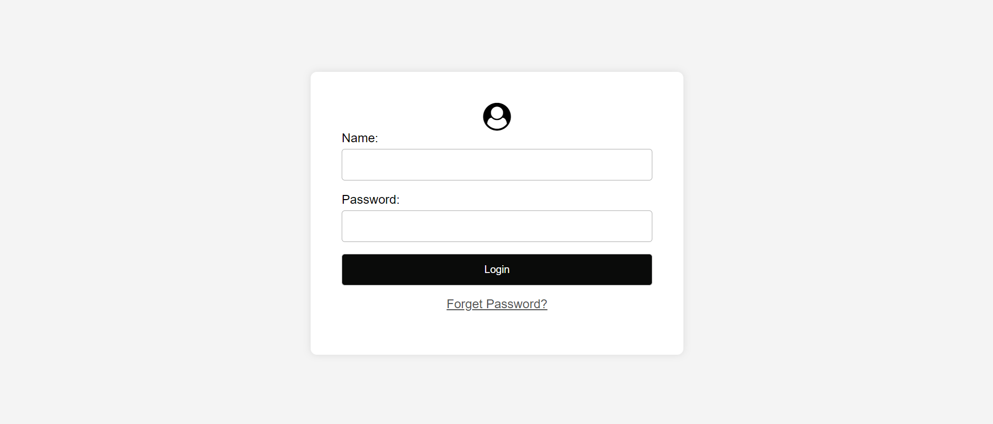
Image 3.7.1 User Login Page
3.7.2 User Home Page:
This is the user home page where users can view a preview of available items or places for booking. Additionally, there is a sidebar on the side for navigation. 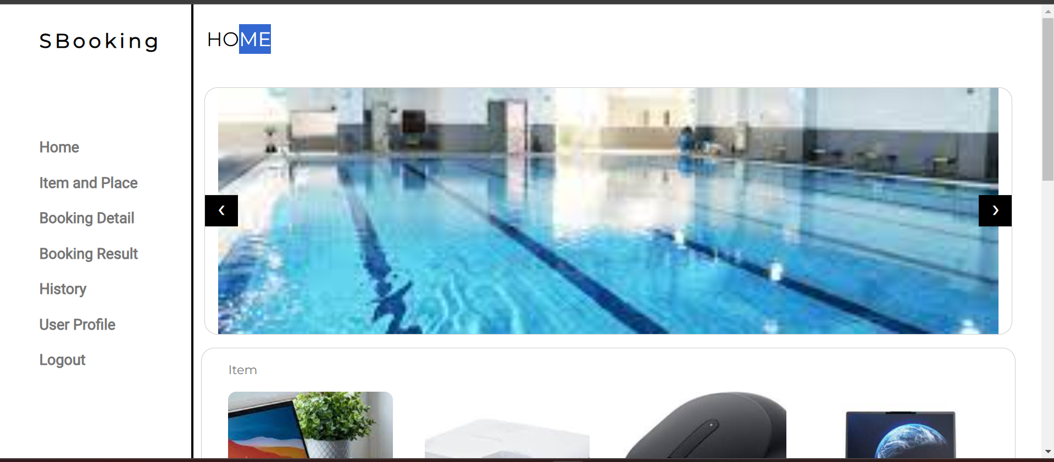
3.7.2 Item Page
This is the item page where users can view all available items. In comparison to the homepage, this page displays a greater number of items for users to explore.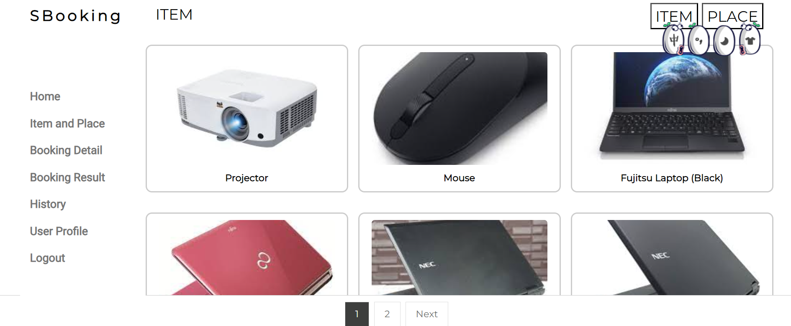
Image 3.7.3 Item Page
3.7.4 Booking Detail (Unactive)
This is the user booking details page, where users can initially see the items they have booked. However, if the booking is still pending approval by the admin, it will be marked as 'unactive.' Once the admin approves the booking, the item details will no longer be displayed here.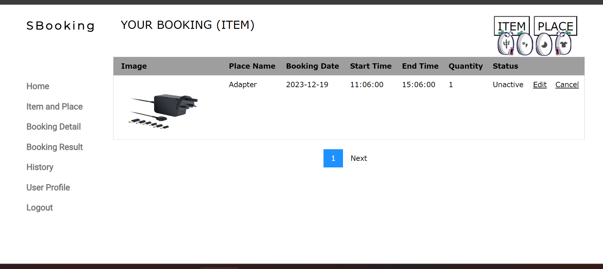
Image 3.7.4 Booking Detail (Unactive)

3.7.5 Admin Login Page:
This is admin basically login page, just have a .login button for admin click to login to their home page.
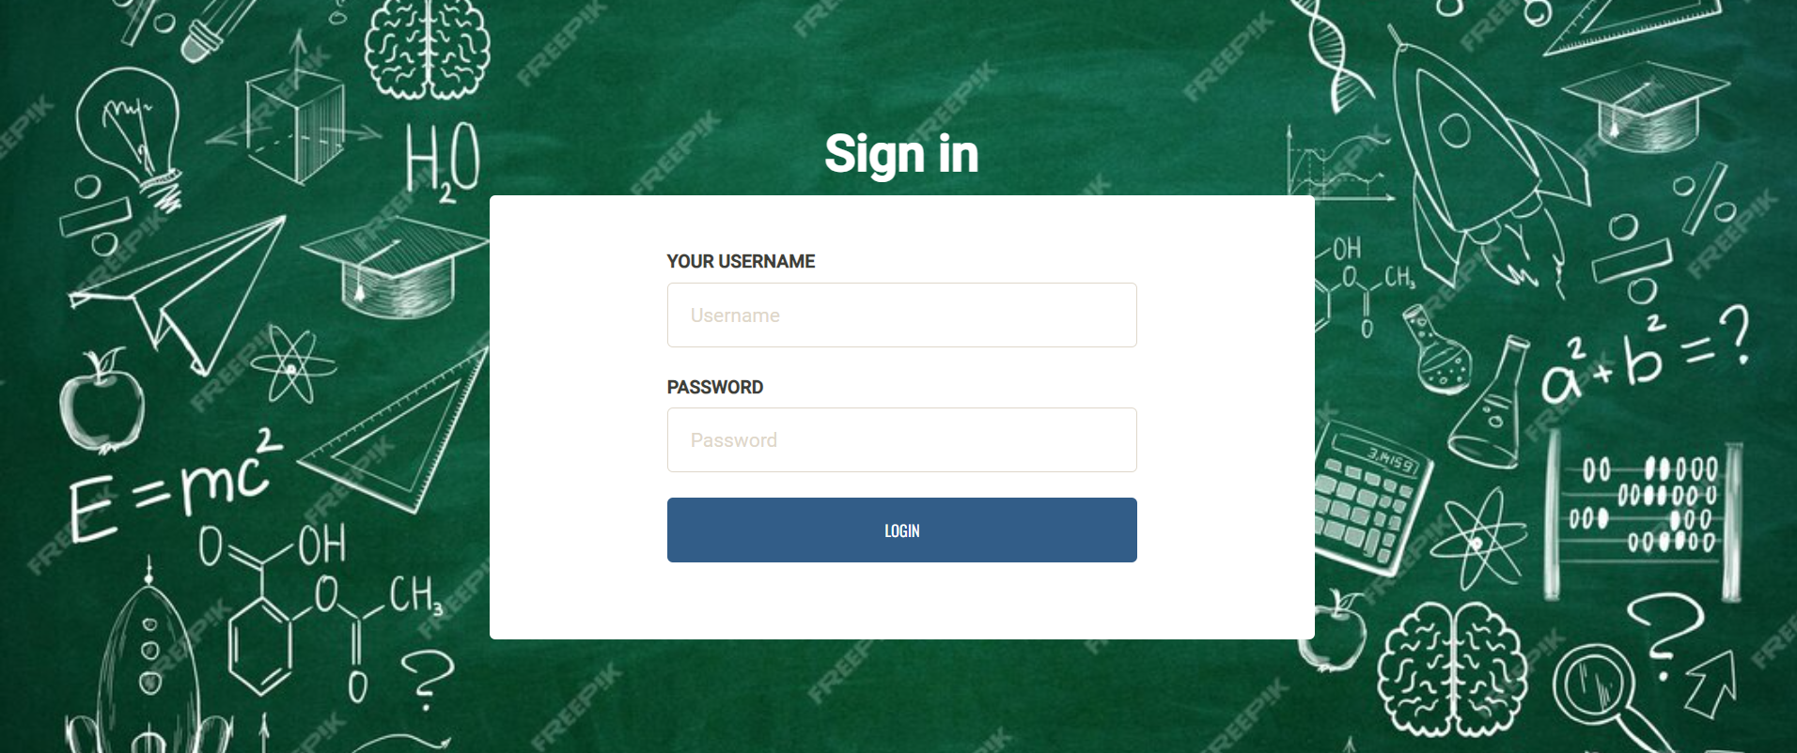
Image 3.7.5 Admin Login Page
3.7.6 Admin Panel Home Page:
This is the admin panel home page, where the dashboard displays comprehensive information, including user details, item list, place list, total item bookings, and total place bookings.
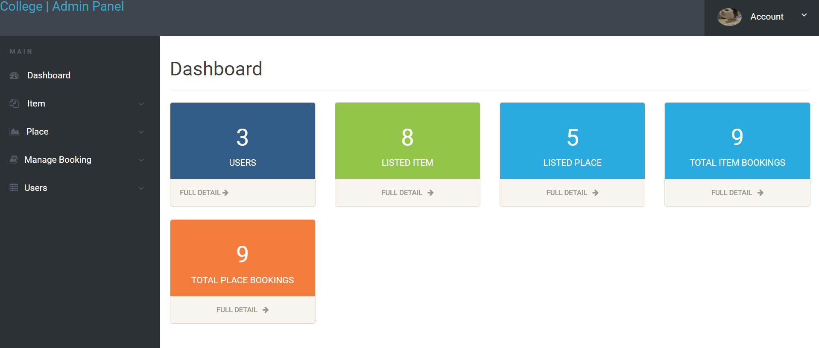
Image 3.7.6 Admin Panel Home Page
3.8 Gantt Chart

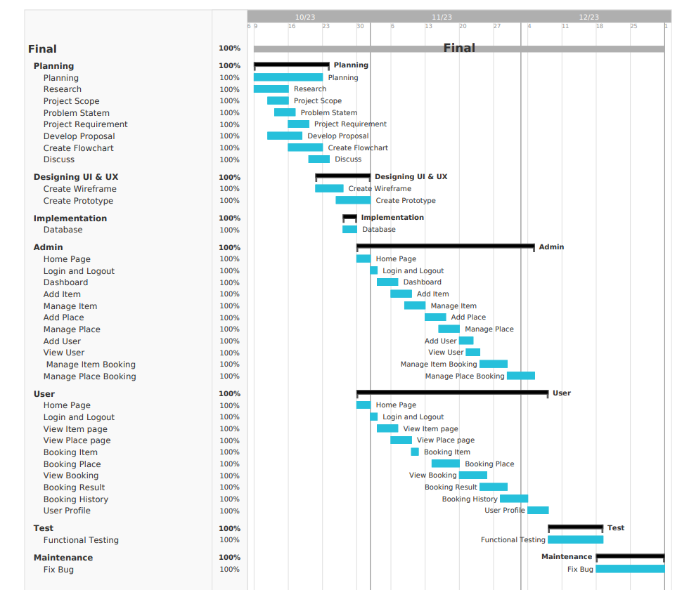

Figure 3.8.1 Gantt Chart

3.9 PROJECT COSTING

3.9.1 SOFTWARE USED AND COSTS

NO | SOFTWARE | COST
1. | WPS Office | -
2. | Visual Studio Code | -
3. | XAMPP Control Panel | -
4. | Iseen Cloud | -

Table 3.9.1 Software used costs

3.9.2 HARDWARE USED AND COSTS

NO | HARDWARE | COST
1. | Laptop | RM 3399.00
2. | Printer | RM 400.00
3. | Mouse | RM 99.00

Table 3.9.2 Hardware used costs

3.9.3 TOTAL COSTS

SOFTWARE COST | HARDWARE COST | TOTAL COST
- | RM 3498.00 | RM 3898.00

Table 3.9.3 Total costs

CHAPTER 4

PROJECT DISCOVERY AND ANALYSIS

4.1 INTRODUCTION

In the rapidly evolving landscape of modern organizations, efficient management of resources plays a pivotal role in ensuring optimal workflow and productivity. One such critical aspect is the effective utilization of facilities, meeting rooms, and shared spaces within an organization. To address this need, we embark on a comprehensive exploration and analysis of a Facilities Booking System, aiming to enhance resource management, streamline booking processes, and elevate the overall operational efficiency of the organization
4.2 DATA ANALYSIS
Data analysis is a crucial process aimed at transforming data into actionable information, enabling a better understanding of data characteristics, and facilitating problem-solving, especially in research and business contexts. Based on the data analysis, it has been observed that the majority of survey respondents fall within the age group of 18 to 29 years. The objective of this survey for Synergy College is to gather up-to-date and real-time information, enhance service quality, and establish a connection with the global audience. This questionnaire has been designed to collect feedback on the E-commerce System website.See Appendix; Survey Form.

4.2.1 WEBSITE STATISTICS AND SURVEY RESULTS
1.
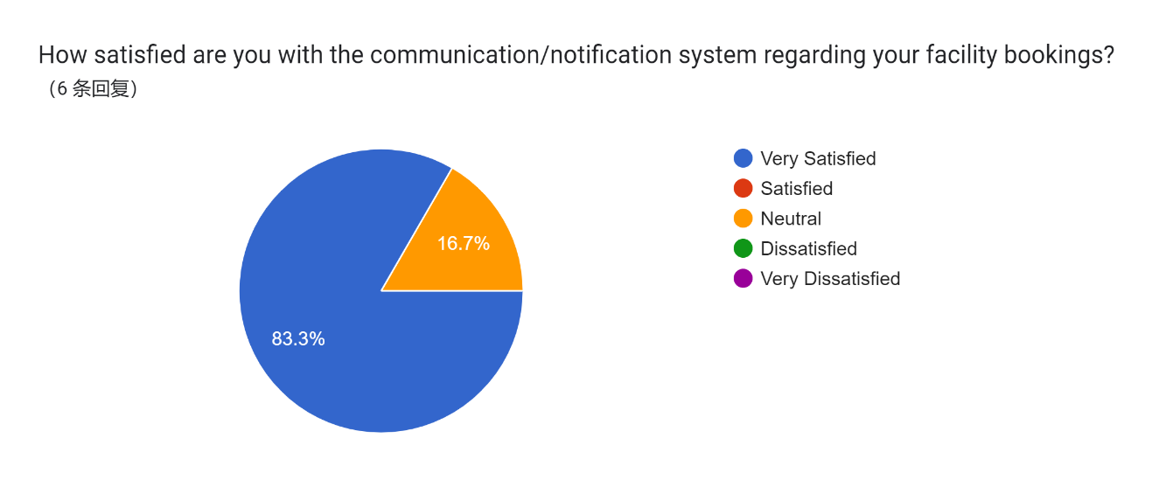

Figure 4.2.1.1 Pie Chart 1

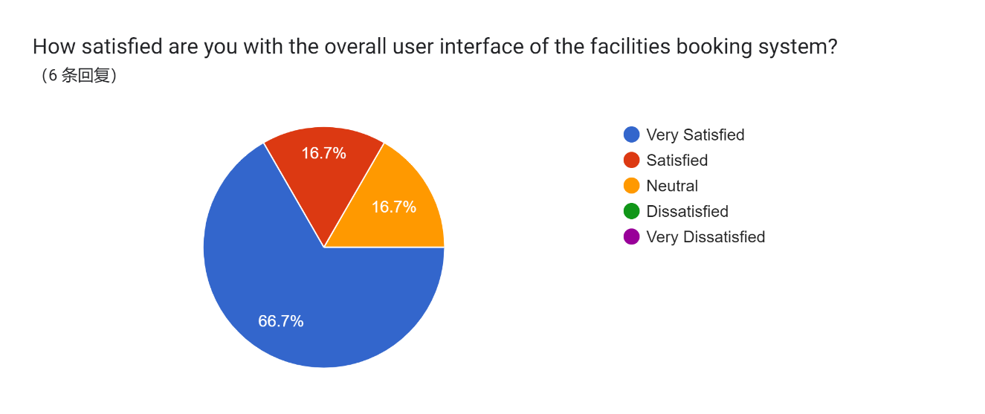
Figure 4.2.1.2 Pie Chart 2

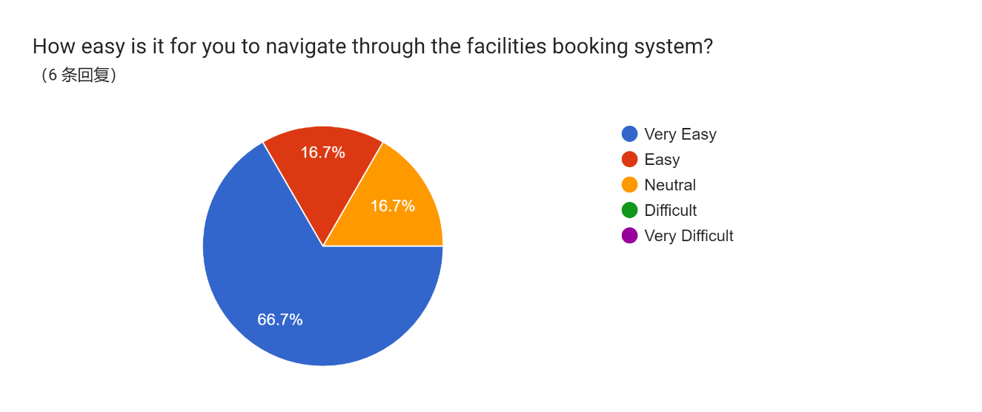
Figure 4.2.1.3 Pie Chart 3

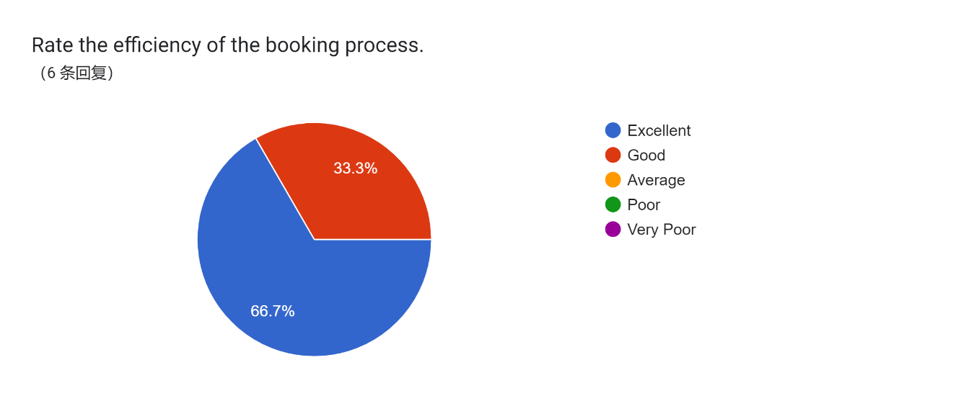
Figure 4.2.1.4 Pie Chart 4

5.
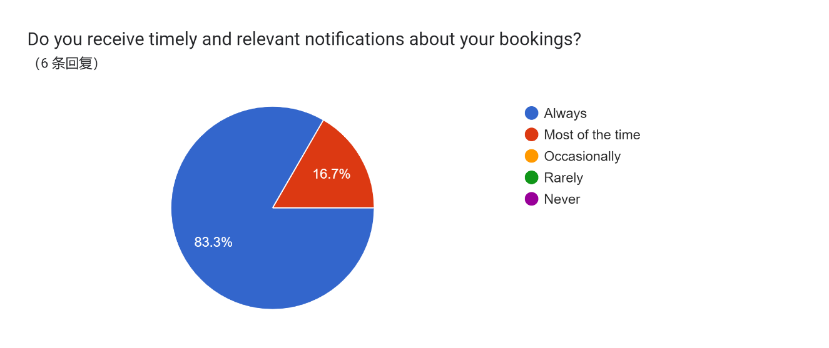
Figure 4.2.1.5 Pie Chart 5

6.
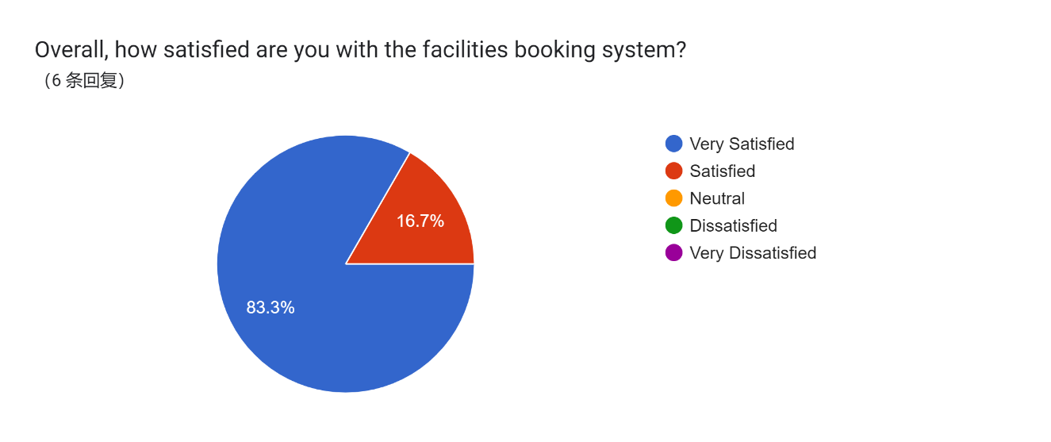
Figure 4.2.1.6 Pie Chart 6
7
7
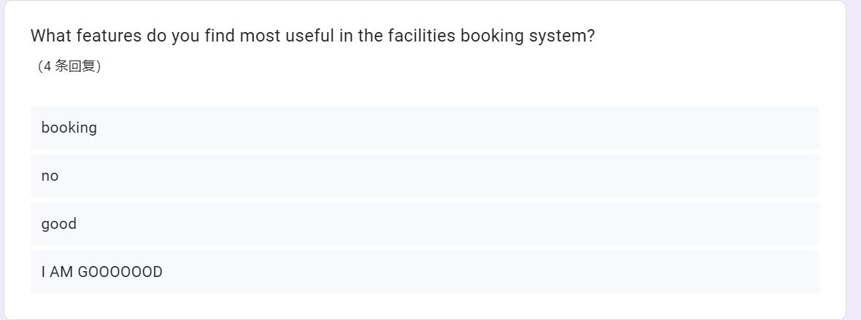
Figure 4.2.1.7 Pie Chart 7

8.
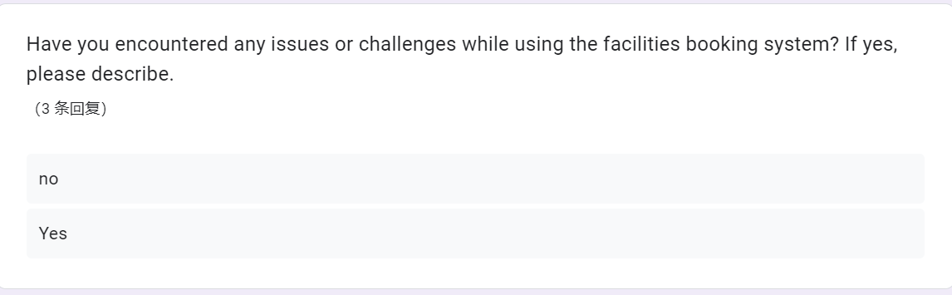
Figure 4.2.1.8 Pie Chart 8
9
. 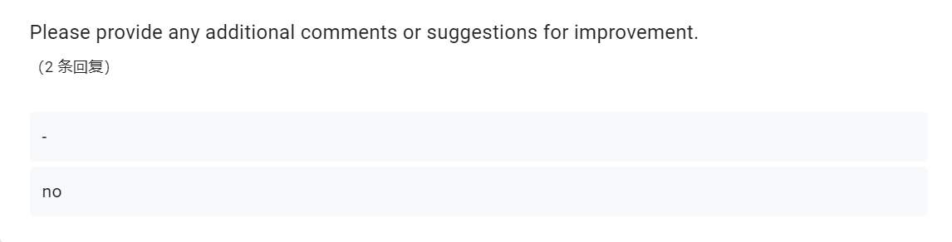
Figure 4.2.1.9 Pie Chart 9

CHAPTER 5

DISCUSSION, RECOMMENDATIONS AND CONCLUSIONS

5.1 DISCUSSION

The development of the Facilities Booking System is geared towards providing the organization with a significantly enhanced platform that ensures the secure storage and management of information. Recognizing that the organization currently relies on a manual, paper-based system, transitioning to a computerized system represents a strategic and beneficial plan. The adoption of a computerized Facilities Booking System offers distinct advantages, empowering users to make prompt, well-informed decisions.

5.1 PROJECT ISSUES

- Based on a reminder alert box to notify the user approximately one hour before, and another alert box to remind the user when the specified time has elapsed, continuing until there is no match in time.

- The dialog for listing items has been consistently malfunctioning due to JavaScript configuration issues, preventing it from running properly.

5.3 SETTLEMENT ISSUES PROJECT

- Conduct a thorough review of the JavaScript code responsible for triggering reminder alerts. Address timing discrepancies to ensure accurate and timely notifications. Implement a mechanism to terminate the alert loop when the specified time has passed. Conduct rigorous testing to validate the effectiveness of the revised reminder alert functionality.
- Conduct a comprehensive audit of the JavaScript configurations associated with the dialog for listing items. Identify and rectify any misconfigurations or errors that are impeding the proper functioning of the dialog. Ensure compatibility with the project's requirements and dependencies. Implement robust testing procedures to validate the correct execution of the dialog for listing items after configuration adjustments.

5.4 RECOMMENDATION

- Experience a sleek and intuitive interface designed for user-friendliness. Navigate seamlessly through the webpage with a clean and modern layout that ensures a delightful user experience.
- Smart Expiry Management:

- Effortlessly manage your items or locations with an intelligent automatic expiry system. Set specific durations, and items or locations will gracefully expire when the designated time arrives, streamlining your organization.
- Proactive Automatic Alerts:

- Stay on top of your schedule with automatic pop-up alerts that proactively remind you of important events or tasks. Whether it's a deadline or a crucial appointment, the system ensures you never miss a beat.
- Effortless Historical Insights:

- Gain valuable insights into your past activities with the ability to view historical records effortlessly. Access a comprehensive overview of your interactions and transactions, empowering you with a clear perspective.
- Secure Password Management:

- Elevate your security with our password management system. Change your passwords seamlessly using a secure verification code sent via email, ensuring robust protection for your sensitive information.

5.5 CONCLUSION

In summary, the proposed e-commerce platform exhibits a comprehensive set of features and functionalities catering to both Super Admins and regular Users. The Super Admin functionalities include robust product management, efficient order processing, dynamic content management, and user administration tools. These features aim to empower administrators with the ability to seamlessly control and optimize the online shopping experience.
For Users, the system offers a streamlined and user-friendly interface. From hassle-free registration to intuitive product browsing and a seamless checkout process, the platform prioritizes simplicity and efficiency. Users can easily manage their profiles, track orders in real-time, and update passwords with confidence.
The combination of advanced functionalities for administrators and a user-centric design for customers establishes a well-balanced and responsive e-commerce ecosystem. The system is poised to enhance operational efficiency for administrators while providing an enjoyable and secure shopping experience for users. As we move forward, continuous refinement and adaptation based on user feedback will be integral to ensuring the platform's ongoing success and relevance in the dynamic landscape of online commerce.

REFERENCES

Reference from Youtube:

Codes Easy . (January 4, 2023) . How to Send Email Using PHPMailer in PHP . (Video.youtube. https://www.youtube.com/watch?v=GmCFeLhA-fA)

Bro Code . (September 22, 2023) . Learn CSS pagination in 8 minutes! 🕮 . (Video.youtube. https://www.youtube.com/watch?v=6ff96BkWqmg)

Skillthrive . (April 29, 2019) . Navbar CSS Tutorial: 3 Ways to Create a Navigation Bar with Flexbox . (Video.youtube. https://www.youtube.com/watch?v=PwWHL3RyQgk)\

Learn Hunter . (July 16, 2021) . Admin Panel design by html css and bootstrap5 | responsive admin template design by bootstrap . (Video.youtube. https://www.youtube.com/watch?v=3NCbRxOE9UU&list=PLbC4KRSNcMnrhSdW137lDtGtfofWcMPnn)

ATTACHMENT
- User Index
- User Login Page:
- <?php
- session_start();

- include_once('db.php');

- if (isset($_POST['submit'])) {
- if (!empty($_POST['username']) && !empty($_POST['password'])) {
- $username = $_POST['username'];
- $userpass = $_POST['password'];

- $query = "SELECT user_id, password FROM user WHERE username = ?";
- $stmt = mysqli_prepare($conn, $query);
- mysqli_stmt_bind_param($stmt, "s", $username);
- mysqli_stmt_execute($stmt);
- $result = mysqli_stmt_get_result($stmt);

- if ($row = mysqli_fetch_assoc($result)) {
- if (password_verify($userpass, $row['password'])) {
- $_SESSION['true'] = true;
- $_SESSION['user_id'] = $row['user_id'];

- header("location: home.php");
- exit;
- } else {
- echo "<script>alert('Login Fail! Please try again.');</script>";
- }
- } else {
- echo "<script>alert('Login Fail! User not found.');</script>";
- }
- } else {
- echo "<script>alert('Please insert both username and password.');</script>";
- }
- }
- ?>

- <!DOCTYPE html>
- <html lang="en">
- <head>
- <meta charset="UTF-8">
- <meta http-equiv="X-UA-Compatible" content="IE=edge">
- <meta name="viewport" content="width=device-width, initial-scale=1.0">
- <link rel="stylesheet" href="https://cdnjs.cloudflare.com/ajax/libs/font-awesome/4.7.0/css/font-awesome.min.css">
- <link rel="stylesheet" href="loginsignup.css">
- <title>Login</title>
- </head>
- <body>
- <div>
- <form action="login.php" method="post">
- <div>
- <i class="fa fa-user-circle" id="user" aria-hidden="true"></i>
- <br>
- <div class="input-container">
- <label for="username"> Name: </label>
- <input type="text" name="username" class="text" required>
- </div>
- <div class="input-container">
- <label for="userpass"> Password: </label>
- <input type="password" name="password" required>
- </div>
- <div>
- <input type="submit" name="submit" value="Login">
- </div>
- <p><a href="forgot_password.php">Forget Password?</a></p>
- </div>
- </form>
- </div>

- <script>
- document.addEventListener('DOMContentLoaded', function() {
- const inputContainers = document.querySelectorAll('.input-container');

- inputContainers.forEach(container => {
- const input = container.querySelector('input');

- input.addEventListener('focus', () => {
- container.classList.add('active');
- });

- input.addEventListener('blur', () => {
- if (input.value === '') {
- container.classList.remove('active');
- }
- });
- });
- });
- </script>
- </body>
- </html>

2) User Home Page:
<?php
include_once('db.php');
include_once('header.php');

if ($_SESSION['true'] !== true) {
header("location: login.php");
exit;
}

$user_id = $_SESSION['user_id'];

$sql = "SELECT * FROM `user` WHERE user_id = ?";
$stmt = mysqli_prepare($conn, $sql);
mysqli_stmt_bind_param($stmt, "i", $user_id);
mysqli_stmt_execute($stmt);
$result = mysqli_stmt_get_result($stmt);

if (mysqli_num_rows($result) === 0) {
header("location: unauthorized.php");
exit;
}

$itemQuery = "SELECT * FROM `item`";
$itemResult = mysqli_query($conn, $itemQuery);

$placeQuery = "SELECT * FROM `place`";
$placeResult = mysqli_query($conn, $placeQuery);

$records_per_page = 4;
if (isset($_GET['item_page'])) {
$page = $_GET['item_page'];
} else {
$page = 1;
}
$set = ($page - 1) * $records_per_page;
$jj = "SELECT * FROM `item` WHERE availability <> 'Not Working' LIMIT $set,$records_per_page";
$result = mysqli_query($conn, $jj);

$records_per_page1 = 4;
if (isset($_GET['place_page'])) {
$place_page = $_GET['place_page'];
} else {
$place_page = 1;
}
$set2 = ($place_page - 1) * $records_per_page1;
$jj2 = "SELECT * FROM `place` WHERE availability <> 'Not Working' LIMIT $set2,$records_per_page1";
$result2 = mysqli_query($conn, $jj2);

// Reset the data pointer to the beginning of the result set
mysqli_data_seek($itemResult, 0);
mysqli_data_seek($placeResult, 0);
?>

<!DOCTYPE html>
<html lang="en">
<head>
<meta charset="UTF-8">
<meta name="viewport" content="width=device-width, initial-scale=1.0">
<link rel="stylesheet" href="https://www.w3schools.com/w3css/4/w3.css">
<link rel="stylesheet" href="https://fonts.googleapis.com/css?family=Roboto">
<link rel="stylesheet" href="https://fonts.googleapis.com/css?family=Montserrat">
<link rel="stylesheet" href="https://cdnjs.cloudflare.com/ajax/libs/font-awesome/4.7.0/css/font-awesome.min.css">
<style>
.w3-sidebar a {font-family: "Roboto", sans-serif}
body,h1,h2,h3,h4,h5,h6,.w3-wide {font-family: "Montserrat", sans-serif;}
</style>
<title>Your Title</title>
</head>
<div style="border-left: 3px solid #000;">
<header class="w3-container w3-xlarge">
<p class="w3-left">HOME</p>
<p class="w3-right">

</p>
</header>
<div style="width: 99%; margin-left: auto;">
<body class="w3-content" style="max-width:1200px">

<div class="w3-panel w3-border w3-round-xlarge w3-content w3-display-container" style="width:100%; height: 300px;">
<img class="mySlides" src="img/basketball.jpg">
<img class="mySlides" src="img/科学室.jpg">
<img class="mySlides" src="img/游泳池.jpg">
<img class="mySlides" src="img/键盘.jpg">

<button class="w3-button w3-black w3-display-left" onclick="plusDivs(-1)">&#10094;</button>
<button class="w3-button w3-black w3-display-right" onclick="plusDivs(1)">&#10095;</button>
</div>

<div class="w3-panel w3-border w3-round-xlarge">
<div class="w3-container w3-text-grey" id="jeans">
<p>Item</p>
</div>

<div class="w3-row">
<?php while ($row = mysqli_fetch_array($itemResult)) { ?>
<div class="w3-col l3 s6">
<div class="w3-container">
<a href="item.php">
<img class="rounded-image" src="img/<?= $row['item_img'] ?>" alt="<?= $row['item_name'] ?>" style="width: 200px; height: 200px;">
<div class="item-name">
<?= $row['item_name'] ?>
</div>
</a>
</div>
</div>
<?php } ?>
</div>
</div>

<div class="w3-panel w3-border w3-round-xlarge">
<div class="w3-container w3-text-grey" id="jeans">
<p>Place</p>
</div>

<div class="w3-row">
<?php while ($row = mysqli_fetch_array($placeResult)) { ?>
<div class="w3-col l3 s6">
<div class="w3-container">
<a href="place.php">
<img class="rounded-image" src="img/<?= $row['place_img'] ?>" alt="<?= $row['place_name'] ?>" style="width: 200px; height: 200px;">
<div class="place-name">
<?= $row['place_name'] ?>
</div>
</a>
</div>
</div>
<?php } ?>
</div>
</div>
</div>
</div>
<script>
var slideIndex = 1;
showDivs(slideIndex);

setInterval(function() {
plusDivs(1);
}, 3000);

function plusDivs(n) {
showDivs(slideIndex += n);
}

function showDivs(n) {
var i;
var x = document.getElementsByClassName("mySlides");
if (n > x.length) { slideIndex = 1; }
if (n < 1) { slideIndex = x.length; }
for (i = 0; i < x.length; i++) {
x[i].style.display = "none";
}
x[slideIndex - 1].style.display = "block";
}

function navigateTo(destination) {
window.location.href = destination;
}
</script>
</body>
</html>
<style>
.w3-content-container {
border: 2px solid #ccc;
object-fit:cover;
width: 80%;
margin: 0 auto;
}

.mySlides {
transition: opacity 3s ease-in-out;
width: 100%;
height: 100%;
object-fit: cover; /* 裁剪并填充，确保照片完全覆盖框 */
}

.w3-container img {
width: 100%;
height: 300px;
object-fit: cover; /* 裁剪并填充，确保照片完全覆盖框 */
}

.rounded-image {
border-radius: 10px; /* 圆角样式，根据需要调整 */
}
</style>

3) Item Page:
<?php
include_once('db.php');
include_once('header.php');

if (isset($_REQUEST['item_book'])) {
if (isset($_POST["item_book"])) {
$item_id = $_POST['item_id'];
$user_id = $_POST['user_id'];
$item_name = trim($_POST['item_name']);
$item_img = $_POST['item_img'];
$item_overview = trim($_POST['item_overview']);
$quantity = $_POST['quantity'];
$booking_date = $_POST['booking_date'];
$start_time = $_POST['start_time'];
$end_time = $_POST['end_time'];

// $booking_date = date('Y/m/d', strtotime($booking_date));
// $start_time = date('H:i:s', strtotime($start_time));
// $end_time = date('H:i:s', strtotime($end_time));

// $availabilityCheckQuery = "SELECT * FROM `item_appointment` WHERE item_id = '$item_id' AND
// (
// ('$start_time' >= start_time AND '$start_time' < end_time) OR
// ('$end_time' > start_time AND '$end_time' <= end_time) OR
// ('$start_time' <= start_time AND '$end_time' >= end_time)
// ) AND
// booking_date = '$booking_date'";
// $availabilityCheckResult = mysqli_query($conn, $availabilityCheckQuery);

// if (mysqli_num_rows($availabilityCheckResult) > 0) {
// $message = "Sorry, the item is not available at the selected date and time.";
// echo "<script>alert('$message'); window.location.href = 'item.php';</script>";
// exit();
// }

// Update the item table quantity
// $updateQuantityQuery = "UPDATE `item` SET quantity = quantity - $quantity WHERE item_id = '$item_id'";
// $updateQuantityResult = mysqli_query($conn, $updateQuantityQuery);

// if (!$updateQuantityResult) {
// // Handle error if the quantity update fails
// error_log("Error updating quantity: " . mysqli_error($conn));
// // Optionally, you can roll back the previous insert operation here
// }

// Insert the appointment
$insertQuery = "INSERT INTO `item_appointment` (item_id, item_name, item_img, user_id, start_time, end_time, booking_date, status, quantity) VALUES ('$item_id', '$item_name', '$item_img', '$user_id', '$start_time', '$end_time', '$booking_date', 'Unactive', '$quantity')";
$result = mysqli_query($conn, $insertQuery);

if ($result) {
$message = "Booking successful!";
echo "<script>alert('$message'); window.location.href = 'item.php';</script>";
exit();
} else {
// Handle error if the insert fails
error_log("Error inserting appointment: " . mysqli_error($conn));
// Optionally, you can roll back the previous quantity update here
}
}
}

$records_per_page = 6;
if (isset($_GET['item_page'])) {
$page = $_GET['item_page'];
} else {
$page = 1;
}

$set = ($page - 1) * $records_per_page;
$jj = "SELECT * FROM `item` WHERE availability <> 'Not Working' LIMIT $set,$records_per_page";
$result = mysqli_query($conn, $jj);
?>

<!DOCTYPE html>
<html lang="en">

<head>
<meta charset="UTF-8">
<meta name="viewport" content="width=device-width, initial-scale=1.0">
<title>Item Page</title>
<link rel="stylesheet" href="bookingpage.css">
</head>
<header class="w3-container w3-xlarge">
<p class="w3-left">ITEM</p>
<p class="w3-right">
<button class="btn" onclick="location.href='item.php'">ITEM</button>
<button class="btn" onclick="location.href='place.php'">PLACE</button>

</p>
</header>
<body>
<div class="custom-table" id="clickable-div">

<?php
$i = 0;
while ($row = mysqli_fetch_array($result)) {
$item = "SELECT SUM(quantity) FROM `item_appointment` WHERE item_id='$row[item_id]' AND status='Approve' GROUP BY item_id";

$qry = mysqli_query($conn, $item);
$num = mysqli_num_rows($qry);
$at=mysqli_fetch_array($qry);
$sub=0;
if($num!==0){
$sub=$at[0];
}else{
$sub=0;
}
$total=$row["quantity"]-$sub;

?>
<div class="td">
<div class="item-container" id="none">
<a href="place.php?id=<?= $row['item_id'] ?>" data-item-overview="<?= $row['item_overview'] ?>"
data-item-quantity="<?=$total?>">
<img class="rounded-image" src="img/<?= $row['item_img'] ?>" alt="<?= $row['item_name'] ?>">
<div class="item-name">
<?= $row['item_name'] ?>
</div>
</a>
</div>
</div>
<?php $i++;
} ?>
</div>

<form action="item.php" method="post" class="dialog-form">
<dialog class="dialog">
<i class="fa fa-close" style="float: right;" autofocus></i>
<h2 id="dialog-title"></h2>
<h2 id="dialog-item-name"></h2>
<img id="dialog-image" src="" alt="Item Image">
<p id="dialog-overview"></p>
<input type="hidden" name="item_id" id="item_id">
<input type="hidden" name="item_name" id="item_name">
<input type="hidden" name="item_img" id="item_img">
<input type="hidden" name="item_overview" id="item_overview">
<input type="hidden" name="user_id" value="<?php echo $_SESSION['user_id']; ?>">
<label for="booking_date">Booking Date:</label>
<input type="date" name="booking_date" id="booking_date" required>
<label for="start_time">Start Time:</label>
<input type="time" name="start_time" id="start_time" required>
<label for="end_time">End Time:</label>
<input type="time" name="end_time" id="end_time" required>

<label for="quantity">Quantity: </label>
<input type="number" name="quantity" id="quantity" value="1" min="1" max="10" required>

<button name="item_book">Book</button>
</dialog>
</form>

<div class="pagination justify-content-center">
<?php
$SQL = "SELECT COUNT(*) FROM item WHERE availability = 'Still Working'";
$result_count = mysqli_query($conn, $SQL);
$row = mysqli_fetch_row($result_count);
$records = $row[0];

$total_pages = ceil($records / $records_per_page);
$pagelink = "";

if ($page >= 2) {
echo "<a href='item.php?item_page=" . ($page - 1) . "'>Prev</a>";
}

for ($i = 1; $i <= $total_pages; $i++) {
if ($i == $page) {
$pagelink .= "<a class='active' href='item.php?item_page=" . $i . "'>" . $i . "</a>";
} else {
$pagelink .= "<a href='item.php?item_page=" . $i . "'>" . $i . "</a>";
}
}

echo $pagelink;

if ($page < $total_pages) {
echo "<a href='item.php?item_page=" . ($page + 1) . "'>Next</a>";
}
?>
</div>
</body>

</html>

<script>
const dialog = document.querySelector("dialog");
const closeButton = document.querySelector(".fa-close");
const dialogTitle = document.getElementById("dialog-title");
const dialogImage = document.getElementById("dialog-image");
const dialogOverview = document.getElementById("dialog-overview");
// const quantity = document.getElementById("quantity").value;

document.querySelectorAll(".item-container a").forEach((link) => {
link.addEventListener("click", (e) => {
e.preventDefault();

const itemTitle = link.querySelector(".item-name").textContent;
const itemImageSrc = "img/" + link.querySelector("img").src.split('/').pop();
const itemUrl = link.getAttribute('href');
const item_id = itemUrl.split('=')[1];
const itemOverview = link.getAttribute('data-item-overview');
const itemQuantity = link.getAttribute('data-item-quantity');

document.getElementById("item_id").value = item_id;
document.getElementById("item_name").value = itemTitle;
document.getElementById("item_img").value = itemImageSrc;
document.getElementById("item_overview").value = itemOverview;
// document.getElementById("quantity").value = itemQuantity;

document.getElementById("quantity").setAttribute("max", itemQuantity);

// Set the quantity input value to 1 or the available quantity, whichever is smaller
document.getElementById("quantity").value = Math.min(1, itemQuantity);

dialogTitle.textContent = itemTitle;
dialogImage.src = itemImageSrc;
dialogOverview.textContent = itemOverview;
dialog.showModal();
});
});

closeButton.addEventListener("click", () => {
dialog.close();
});

dialog.querySelector("*").addEventListener("click", (e) => {
e.stopPropagation();
});
</script>

4)Booking Detail:
<?php
include_once('db.php');
include_once('header.php');

$user_id = $_SESSION['user_id'];
$records_per_page = 3;
$page = isset($_GET['page']) ? max(1, intval($_GET['page'])) : 1;
$offset = ($page - 1) * $records_per_page;

// Query for items
$item_query = "
SELECT 'item' as type, ia.itembook_id as book_id, ia.item_img as img, ia.item_name as name, ia.booking_date, ia.start_time, ia.end_time, ia.status , ia.quantity
FROM `item_appointment` ia
WHERE ia.`user_id` = $user_id AND ia.`status` = 'unactive'
LIMIT $offset, $records_per_page
";

$item_result = mysqli_query($conn, $item_query);

// Calculate total pages for items
$item_count_query = "SELECT COUNT(*) FROM `item_appointment` WHERE `user_id` = $user_id AND `status` = 'unactive'";
$item_count_result = mysqli_query($conn, $item_count_query);
$item_row = mysqli_fetch_row($item_count_result);
$item_records = $item_row[0];
$total_item_pages = ceil($item_records / $records_per_page);

if (isset($_POST['edit']) && isset($_POST['itembook_id'])) {
$itembook_id = $_POST['itembook_id'];
$booking_date = $_POST['booking_date'];
$start_time = $_POST['start_time'];
$end_time = $_POST['end_time'];

$query1 = "UPDATE `item_appointment` SET booking_date=?, start_time=?, end_time=? WHERE itembook_id=?";

$stmt = mysqli_prepare($conn, $query1);
mysqli_stmt_bind_param($stmt, "sssi", $booking_date, $start_time, $end_time, $itembook_id);

if (mysqli_stmt_execute($stmt)) {
echo "<script>window.location.href = 'booking_item.php';alert('Record Successfully Edited');</script>";
} else {
echo "<script>alert('Record Fails to Edit')</script>";
}

mysqli_stmt_close($stmt);
}

?>

<!DOCTYPE html>
<html lang="en">
<link rel="stylesheet" href="https://www.w3schools.com/w3css/4/w3.css">
<link rel="stylesheet" href="booking_page.css">
<header class="w3-container w3-xlarge">
<p class="w3-left">YOUR BOOKING (ITEM)</p>
<p class="w3-right">
<button class="btn" onclick="location.href='booking_item.php'">ITEM</button>
<button class="btn" onclick="location.href='booking_place.php'">PLACE</button>
</p>
</header>
<body>

<!-- Display Items Table -->
<div class="ctable">

<table class="w3-table-all">
<thead>
<tr class="w3-grey">
<th>Image</th>
<th>Place Name</th>
<th>Booking Date</th>
<th>Start Time</th>
<th>End Time</th>
<th>Quantity</th>
<th>Status</th>
<th></th>
<th></th>
</tr>
</thead>
<?php while ($row = mysqli_fetch_array($item_result)) { ?>
<tr class="<?= $row['status'] === 'unactive' ? 'unactive-row' : 'active-row' ?>">
<td>
<img class="rounded-image" src="<?= $row['img'] ?>">
</td>
<td>
<?= $row['name'] ?>
</td>
<td>
<?= $row['booking_date'] ?>
</td>
<td>
<?= $row['start_time'] ?>
</td>
<td>
<?= $row['end_time'] ?>
</td>
<td>
<?= $row['quantity'] ?>
</td>
<td>
<?= $row['status'] ?>
</td>
<td>
<a href="#" class="edit-link" data-itembook-id="<?= $row['book_id'] ?>">Edit</a>
</td>
<td>
<a href="cancel_item.php?itembook_id=<?= $row['book_id'] ?>">Cancel</a>
</td>
</tr>
<?php } ?>
</table>

<?php if (mysqli_num_rows($item_result) > 0) { ?>
<table>
<!-- ... (Your existing table rows) -->
</table>
<?php } else { ?>
<div class="no-appointments">
<p>No appointments found.</p>
<p>Feel free to schedule new appointments!</p>
</div>
<?php } ?>

<!-- Items Pagination -->
<div class="pagination justify-content-center">
<?php
if ($page > 1) {
echo "<a href='booking_item.php?page=" . ($page - 1) . "&type=item'>Prev</a>";
}

for ($i = 1; $i <= $total_item_pages; $i++) {
echo "<a " . ($i == $page ? "class='active'" : "") . " href='booking_item.php?page=" . $i . "&type=item'>" . $i . "</a>";
}

// Check if there are records in the next page
$hasNextPage = ($page < $total_item_pages);

if ($hasNextPage) {
echo "<a href='booking_item.php?page=" . ($page + 1) . "&type=item'>Next</a>";
} elseif ($page >= $total_item_pages && $total_item_pages > 0) {
echo "<a class='disabled'>Next</a>";
}
?>
</div>

</div>

<form action="form-horizontal" action="booking_item.php" method="post" class="dialog-form">
<dialog id="editDialog">
<i class="fa fa-close" style="float: right;" autofocus></i>
<h2 id="editDialogTitle"></h2>
<div class="container">
<input type="hidden" name="itembook_id" id="editItembookId">
<div>
<label>Booking Date:</label>
<div>
<input type="date" name="booking_date" id="editBookingDate" required>
</div>
</div>
<div>
<label>Start Time:</label>
<div>
<input type="time" name="start_time" id="editStartTime" required>
</div>
</div>
<div>
<label>End Time:</label>
<div>
<input type="time" name="end_time" id="editEndTime" required>
</div>
</div>
<br />
<div>
<div>
<button type="submit" name="edit" value="edit">Submit</button>
<!-- <button type="button" onclick="window.location.href='booking_item.php'">Back</button> -->
</div>
</div>

</div>
</dialog>
</form>

</body>

</html>

<script>
const closeButton = document.querySelector(".fa-close");
const editLinks = document.querySelectorAll(".edit-link");
const dialog = document.getElementById('editDialog');
const dialogTitle = document.getElementById('editDialogTitle');
const itembookIdInput = document.getElementById('editItembookId');
const bookingDateInput = document.getElementById('editBookingDate');
const startTimeInput = document.getElementById('editStartTime');
const endTimeInput = document.getElementById('editEndTime');

editLinks.forEach((link) => {
link.addEventListener("click", (event) => {
event.preventDefault();

const itembook_id = link.getAttribute('data-itembook-id');
const booking_date = link.getAttribute('data-booking-date');
const start_time = link.getAttribute('data-start-time');
const end_time = link.getAttribute('data-end-time');

itembookIdInput.value = itembook_id;
bookingDateInput.value = booking_date;
startTimeInput.value = start_time;
endTimeInput.value = end_time;

dialog.showModal();
});
});

closeButton.addEventListener("click", () => {
dialog.close();
});

function redirectToURL(url) {
window.location.href = url;
}
</script>

<!-- <style>
dialog {
flex-direction: column;
align-items: center;
padding: 20px;
background-color: #fff;
border: 2px solid #0f0e0e;
border-radius: 10px;
}
.dialog-form {
max-width: 300px;
margin: 0 auto;
background-color: #fff;
border-radius: 8px;
box-shadow: 0 0 10px rgba(0, 0, 0, 0.1);
text-align: center;
}

.dialog-form label {
display: block;
margin-bottom: 8px;
font-weight: bold;
}

.dialog-form input {
width: 100%;
padding: 8px;
margin-bottom: 16px;
box-sizing: border-box;
}

.dialog-form button {
background-color: #343634;
color: #fff;
padding: 10px 20px;
border: none;
border-radius: 4px;
cursor: pointer;
font-size: 16px;
}

.dialog-form button:hover {
background-color: #484848;
}

.header {
position: relative;
z-index: 1;
/* Set a value smaller than varbar's z-index */
}
.ctable {
display: flex;
flex-direction: column;
justify-content: center;
align-items: center;
min-height: 50vh;
}

.rounded-image {
border-radius: 20px;
width: 200px;
height: 120px;
}

.pagination {
display: flex;
justify-content: center;
list-style: none;
padding: 0;
margin-top: 20px;
}

.pagination a {
color: black;
padding: 8px 16px;
text-decoration: none;
transition: background-color 0.3s;
}

.pagination a.active {
background-color: dodgerblue;
color: white;
}

.pagination a:hover:not(.active) {
background-color: #ddd;
}
.no-appointments {
text-align: center;
padding: 20px;
border: 2px solid #ccc;
border-radius: 10px;
background-color: #f9f9f9;
margin: 20px;
}

.no-appointments p {
margin: 10px 0;
font-size: 18px;
color: #555;
}
.btn {
background-color: #fff;
}

</style> -->

5)Admin Login Page:
<?php
session_start();
include('includes/config.php');
if(isset($_POST['login']))
{
$email=$_POST['username'];
$password=md5($_POST['password']);
$sql ="SELECT UserName,Password FROM admin WHERE UserName=:email and Password=:password";
$query= $dbh -> prepare($sql);
$query-> bindParam(':email', $email, PDO::PARAM_STR);
$query-> bindParam(':password', $password, PDO::PARAM_STR);
$query-> execute();
$results=$query->fetchAll(PDO::FETCH_OBJ);
if($query->rowCount() > 0)
{
$_SESSION['alogin']=$_POST['username'];
echo "<script type='text/javascript'> document.location = 'dashboard.php'; </script>";
} else{

echo "<script>alert('Invalid Details');</script>";

}

}

?>
<!doctype html>
<html lang="en" class="no-js">

<head>
<meta charset="UTF-8">
<meta http-equiv="X-UA-Compatible" content="IE=edge">
<meta name="viewport" content="width=device-width, initial-scale=1, minimum-scale=1, maximum-scale=1">
<meta name="description" content="">
<meta name="author" content="">

<title>College | Admin Login</title>
<link rel="stylesheet" href="css/font-awesome.min.css">
<link rel="stylesheet" href="css/bootstrap.min.css">
<link rel="stylesheet" href="css/dataTables.bootstrap.min.css">
<link rel="stylesheet" href="css/bootstrap-social.css">
<link rel="stylesheet" href="css/bootstrap-select.css">
<link rel="stylesheet" href="css/fileinput.min.css">
<link rel="stylesheet" href="css/awesome-bootstrap-checkbox.css">
<link rel="stylesheet" href="css/style.css">
</head>

<body>

<div class="login-page bk-img" style="background-image: url(aimg/adminlogin.jpg);">
<div class="form-content">
<div class="container">
<div class="row">
<div class="col-md-6 col-md-offset-3">
<h1 class="text-center text-bold text-light mt-4x">Sign in</h1>
<div class="well row pt-2x pb-3x bk-light">
<div class="col-md-8 col-md-offset-2">
<form method="post">

<label for="" class="text-uppercase text-sm">Your Username </label>
<input type="text" placeholder="Username" name="username" class="form-control mb">

<label for="" class="text-uppercase text-sm">Password</label>
<input type="password" placeholder="Password" name="password" class="form-control mb">

<button class="btn btn-primary btn-block" name="login" type="submit">LOGIN</button>

</form>
</div>
</div>
</div>
</div>
</div>
</div>
</div>

<!-- Loading Scripts -->
<script src="js/jquery.min.js"></script>
<script src="js/bootstrap-select.min.js"></script>
<script src="js/bootstrap.min.js"></script>
<script src="js/jquery.dataTables.min.js"></script>
<script src="js/dataTables.bootstrap.min.js"></script>
<script src="js/Chart.min.js"></script>
<script src="js/fileinput.js"></script>
<script src="js/chartData.js"></script>
<script src="js/main.js"></script>

</body>

</html>

6)Admin Home Page/Dashboard:
<?php
session_start();
error_reporting(0);
include('includes/config.php');
if (strlen($_SESSION['alogin']) == 0) {
header('location:index.php');
} else {
?>
<!doctype html>
<html lang="en" class="no-js">

<head>
<meta charset="UTF-8">
<meta http-equiv="X-UA-Compatible" content="IE=edge">
<meta name="viewport" content="width=device-width, initial-scale=1, minimum-scale=1, maximum-scale=1">
<meta name="description" content="">
<meta name="author" content="">
<meta name="theme-color" content="#3e454c">

<title>College | Admin Dashboard</title>

<!-- Font awesome -->
<link rel="stylesheet" href="css/font-awesome.min.css">
<!-- Sandstone Bootstrap CSS -->
<link rel="stylesheet" href="css/bootstrap.min.css">
<!-- Bootstrap Datatables -->
<link rel="stylesheet" href="css/dataTables.bootstrap.min.css">
<!-- Bootstrap social button library -->
<link rel="stylesheet" href="css/bootstrap-social.css">
<!-- Bootstrap select -->
<link rel="stylesheet" href="css/bootstrap-select.css">
<!-- Bootstrap file input -->
<link rel="stylesheet" href="css/fileinput.min.css">
<!-- Awesome Bootstrap checkbox -->
<link rel="stylesheet" href="css/awesome-bootstrap-checkbox.css">
<!-- Admin Stye -->
<link rel="stylesheet" href="css/style.css">
</head>

<body>
<?php include('includes/header.php'); ?>

<div class="ts-main-content">
<?php include('includes/leftbar.php'); ?>
<div class="content-wrapper">
<div class="container-fluid">

<div class="row">
<div class="col-md-12">

<h2 class="page-title">Dashboard</h2>

<div class="row">
<div class="col-md-12">
<div class="row">
<div class="col-md-3">
<div class="panel panel-default">
<div class="panel-body bk-primary text-light">
<div class="stat-panel text-center">
<?php
$sql = "SELECT user_id from user ";
$query = $dbh->prepare($sql);
$query->execute();
$results = $query->fetchAll(PDO::FETCH_OBJ);
$regusers = $query->rowCount();
?>
<div class="stat-panel-number h1 ">
<?php echo htmlentities($regusers); ?>
</div>
<div class="stat-panel-title text-uppercase">Users</div>
</div>
</div>
<a href="user_manage.php" class="block-anchor panel-footer">Full Detail <i
class="fa fa-arrow-right"></i></a>
</div>
</div>
<div class="col-md-3">
<div class="panel panel-default">
<div class="panel-body bk-success text-light">
<div class="stat-panel text-center">
<?php
$sql1 = "SELECT item_id from item ";
$query1 = $dbh->prepare($sql1);
;
$query1->execute();
$results1 = $query1->fetchAll(PDO::FETCH_OBJ);
$totalitem = $query1->rowCount();
?>
<div class="stat-panel-number h1 ">
<?php echo htmlentities($totalitem); ?>
</div>
<div class="stat-panel-title text-uppercase">Listed Item</div>
</div>
</div>
<a href="manage-item.php" class="block-anchor panel-footer text-center">Full
Detail &nbsp; <i class="fa fa-arrow-right"></i></a>
</div>
</div>
<div class="col-md-3">
<div class="panel panel-default">
<div class="panel-body bk-info text-light">
<div class="stat-panel text-center">
<?php
$sql2 = "SELECT place_id from place ";
$query2 = $dbh->prepare($sql2);
;
$query2->execute();
$results2 = $query2->fetchAll(PDO::FETCH_OBJ);
$totalplace = $query2->rowCount();
?>
<div class="stat-panel-number h1 ">
<?php echo htmlentities($totalplace); ?>
</div>
<div class="stat-panel-title text-uppercase">Listed Place</div>
</div>
</div>
<a href="manage-place.php"
class="block-anchor panel-footer text-center">Full Detail &nbsp; <i
class="fa fa-arrow-right"></i></a>
</div>
</div>
<div class="col-md-3">
<div class="panel panel-default">
<div class="panel-body bk-info text-light">
<div class="stat-panel text-center">
<?php
$sql3 = "SELECT itembook_id from item_appointment ";
$query3 = $dbh->prepare($sql3);
$query3->execute();
$results3 = $query3->fetchAll(PDO::FETCH_OBJ);
$itembookings = $query3->rowCount();
?>

<div class="stat-panel-number h1 ">
<?php echo htmlentities($itembookings); ?>
</div>
<div class="stat-panel-title text-uppercase">Total Item Bookings
</div>
</div>
</div>
<a href="booking_item.php"
class="block-anchor panel-footer text-center">Full Detail &nbsp; <i
class="fa fa-arrow-right"></i></a>
</div>
</div>
<div class="col-md-3">
<div class="panel panel-default">
<div class="panel-body bk-warning text-light">
<div class="stat-panel text-center">
<?php
$sql4 = "SELECT placebook_id from place_appointment ";
$query4 = $dbh->prepare($sql4);
$query4->execute();
$results4 = $query4->fetchAll(PDO::FETCH_OBJ);
$placebookings = $query4->rowCount();
?>

<div class="stat-panel-number h1 ">
<?php echo htmlentities($placebookings); ?>
</div>
<div class="stat-panel-title text-uppercase">Total Place Bookings
</div>
</div>
</div>
<a href="booking_place.php"
class="block-anchor panel-footer text-center">Full Detail &nbsp; <i
class="fa fa-arrow-right"></i></a>
</div>
</div>

<!-- Loading Scripts -->
<script src="js/jquery.min.js"></script>
<script src="js/bootstrap-select.min.js"></script>
<script src="js/bootstrap.min.js"></script>
<script src="js/jquery.dataTables.min.js"></script>
<script src="js/dataTables.bootstrap.min.js"></script>
<script src="js/Chart.min.js"></script>
<script src="js/fileinput.js"></script>
<script src="js/chartData.js"></script>
<script src="js/main.js"></script>

<script>

window.onload = function () {

// Line chart from swirlData for dashReport
var ctx = document.getElementById("dashReport").getContext("2d");
window.myLine = new Chart(ctx).Line(swirlData, {
responsive: true,
scaleShowVerticalLines: false,
scaleBeginAtZero: true,
multiTooltipTemplate: "<%if (label){%><%=label%>: <%}%><%= value %>",
});

// Pie Chart from doughutData
var doctx = document.getElementById("chart-area3").getContext("2d");
window.myDoughnut = new Chart(doctx).Pie(doughnutData, { responsive: true });

// Dougnut Chart from doughnutData
var doctx = document.getElementById("chart-area4").getContext("2d");
window.myDoughnut = new Chart(doctx).Doughnut(doughnutData, { responsive: true });

}
</script>
</body>

</html>
<?php } ?>

